

Research Report

Prepared For: | Sarah Reese | Request Date: | 8/12/2015
Business Name: | City of Laramie | Promised Date: | 8/21/2015
Counselor: | Mike Lambert | Delivery Date: | 8/21/2015
Organization: | SBDC | Hours Spent: | 9.67
Information Requested: | - City of Laramie Data  - Major Marketplace/Retail Location  - Overall Market Analysis  - Laramie Psychographics  - Population and household Trends: 2010 vs. 2015  - Laramie Unique Retailers  - Competition: Cheyenne & Fort Collins Markets  - Retail Data  - Retail Marketplace Profile: Albany, Laramie, and University Campus  - Laramie Consumer Spending Reports: 2015 and 2020  - Cheyenne Consumer Spending Reports: 2015 and 2020  - Fort Collins Consumer Spending Reports: 2015 and 2010  - Retail Stores Opportunity Gaps  - Retail Sectors where Laramie has Competitive Advantage: Tourism  - Laramie Retail Areas Not Meeting their Full Potential  - Retail Trends: Strengths and Weaknesses
Description of Material Delivered: | Information Above
WMRC Resources Used: | Claritas, ESRI

Thank you for the opportunity to assist you. The information contained in this report is deemed accurate. However, as with any research, the results contained here should be weighed against the experience and personal knowledge of the individual business person. If you have any questions, or if I can be of further service, please feel free to contact me or the Economic Development Professional who referred you to the Wyoming Market Research Center.

Marie Makepeace
Wyoming Market Research Center
Dept 3922, 1000 E. University Avenue
Laramie, WY 82071
tel: (307) 766- 56472
email: jmakepe1@uwyo.edu

WE NEED YOUR FEEDBACK – We are required to monitor the success of our program in order to guarantee continued funding for the Market Research Center. Please take our short survey by clicking the link below. Thank you.

https://survey.uwyo.edu/TakeSurvey.aspx?SurveyID=96K06ol02

Note: Hold down the CTRL key when clicking the link, or copy and paste the address into your browser.

Contents of Report:
- City of Laramie Data
- Major Marketplace/Retail Location
- Overall Market Analysis
- Laramie Psychographics
- Laramie Demographics
- Population and household Trends: 2010 vs. 2015
- Laramie Unique Retailers
- Competition: Cheyenne & Fort Collins Markets
- Retail Data
- Retail Marketplace Profile: Albany, Laramie, and University Campus
- Laramie Consumer Spending Reports: 2015 and 2020
- Cheyenne Consumer Spending Reports: 2015 and 2020
- Fort Collins Consumer Spending Reports: 2015 and 2010
- Retail Sectors where Laramie has Competitive Advantage: Tourism

- City of Laramie Data
  - Major Marketplace/Retail Location
Using Reference USA a list of 472 retail businesses were found in Laramie, Wyoming. Reference USA, like all of the major business databases (Hoovers and AtoZ are the other two key competitors) uses custom algorithms to estimate company staffing levels and sales. This modeling may result in sales that are not in line with what you know, but since the only organization that has access to detailed financial information is the IRS, and they are prohibited from sharing this data, the database industry has to use estimates. Another issue that can crop us is that much of the industry data is self-reported, so it is not uncommon for a company to be shown in an incorrect industry classification.
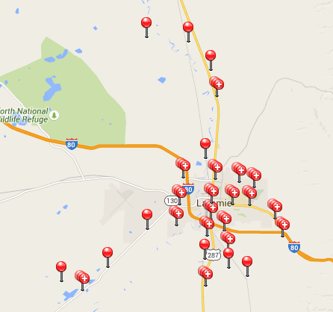

A closer view of Laramie shows the majority of retail is along Grand Avenue and 3rd street. The map below displays the clusters of retail areas throughout Laramie.
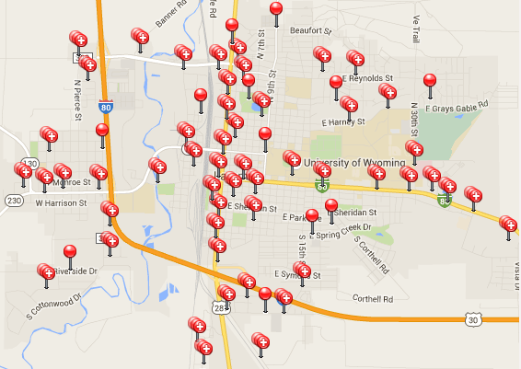

  - Overall Market Analysis
Using the list from part A, the businesses were organized by NAICS code. NAICS code is the standard used by Federal statistical agencies in classifying business establishments for the purpose of collecting, analyzing, and publishing statistical data related to the U.S. business economy.

The table below contains a list of the most popular NAICS codes that correspond with Laramie businesses. The type of retail business with the most establishments in Laramie is Full Service Restaurants with 55 businesses.

Primary NAICS | Primary NAICS | Record Count
72251117 | FULL to SERVICE RESTAURANTS | 55
45411101 | ELECTRONIC SHOPPING | 44
72251301 | LIMITED to SERVICE RESTAURANTS | 26
44512001 | CONVENIENCE STORES | 10
44531004 | BEER, WINE & LIQUOR STORES | 10
44314247 | ELECTRONIC STORES | 9
72251505 | SNACK & NONALCOHOLIC BEVERAGE BARS | 9
72241001 | DRINKING PLACES ALCOHOLIC BEVERAGES | 8
44613003 | OPTICAL GOODS STORES | 8
44111001 | NEW CAR DEALERS | 7
44719005 | OTHER GASOLINE STATIONS | 7
44419069 | OTHER BUILDING MATERIAL DEALERS | 6
31181102 | RETAIL BAKERIES | 6
44131011 | AUTOMOTIVE PARTS & ACCESSORIES STORES | 6
44812010 | WOMEN'S CLOTHING STORES | 6
44611009 | PHARMACIES & DRUG STORES | 6
45111055 | SPORTING GOODS STORES | 6
44411001 | HOME CENTERS | 5
44419029 | OTHER BUILDING MATERIAL DEALERS | 5
44422029 | NURSERY, GARDEN CENTER & FARM SUPPLY STORES | 5
44211012 | FURNITURE STORES | 5
44619903 | ALL OTHER HEALTH & PERSONAL CARE STORES | 5

Some of NAICS codes that appear multiple times are incorporated as part of another business. For example, Electronic Shopping is listed 9 times. This is a result of many businesses having online shopping websites in addition to their physical locations.

The table below contains all the NAICS codes with at least five businesses associated with them; however there were many NAICS codes that were only associated with one or two business. The full list of codes can be found in the excel file below.

  - Laramie Psychographics
Psychographics go beyond the external to focus on your target customers' psychology, lifestyles, and behaviors. Psychographics can include such factors as where your target customers like to travel on vacation, the kinds of hobbies and interests they have, the values or opinions they hold, and how they behave. It's been said that demographics help you understand who buys your product or service, while psychographics helps you understand why they buy.
We use psychographic data from Neilsen Claritas. Their Prism model assigns every household in the US to one of 66 psychographic classifications. Households in a psychographic class share common demographic profiles, but also share common purchasing and media behaviors. Studying these profiles can help you understand the consumers you are trying to reach.
The following table contains a brief summary of Laramie’s psychographic segments and their respective percentage of the total area population.

Psychographic Segment | Population Percentage
City Startups    In City Startups, young to middle-aged, multi-ethnic singles have settled in neighborhoods filled with cheap apartments and a commercial base of cafés, bars, Laundromats, and clubs that cater to twenty-somethings. One of the youngest segments in America--with ten times as many college students as the national average--these neighborhoods feature low incomes and high concentrations of African-American and Hispanic households. | 21.31
Young & Rustic    Young & Rustic is composed of middle-aged, restless singles. These folks tend to be lower-middle-income, high school-educated, and live in tiny apartments in the nation's exurban towns. With their service industry jobs and modest incomes, these folks still try to fashion fast-paced lifestyles centered on sports, cars, and dating. | 11.75
Up-and-Comers    Up-and-Comers is a stopover for younger, upper-midscale singles before they marry, have families, and establish more deskbound lifestyles. Found in second-tier cities, these mobile adults, mostly age 25 to 44; include a disproportionate number of recent college graduates who are into athletic activities, the latest technology, and nightlife entertainment. | 11.20
Boomtown Singles    Affordable housing, abundant entry-level jobs, and a thriving singles scene--all have given rise to the Boomtown Singles segment in fast-growing satellite cities. Single and working-class, these residents pursue active lifestyles amid sprawling apartment complexes, bars, convenience stores, and Laundromats. | 10.73
Brite Lites, Li’l City    Not all of America's chic sophisticates live in major metros. Brite Lights, Li'l City is a group of well-off, middle-aged couples settled in the nation's satellite cities. Residents of these typical DINK (double income, no kids) households have college educations, well-paying business and professional careers, and swank homes filled with the latest technology. | 7.60
  Greenbelt Sports  A segment of upscale exurban couples, Greenbelt Sports is known for its active lifestyle. Most of these older residents are married, college-educated, and own new homes. And few segments have higher rates for pursuing outdoor activities such as skiing, canoeing, backpacking, boating, and mountain biking. | 6.09
  Mobility Blues  Mobility Blues is a segment of middle-age singles in working-class neighborhoods in America's satellite cities. Ethnically diverse, these transient Americans tend to have modest lifestyles due to their lower income jobs. Surveys show they excel in going to movies, playing basketball, and shooting pool | 3.99
Red, White & Blues    The residents of Red, White & Blues typically live in exurban towns rapidly morphing into bedroom suburbs. Their streets feature new fast-food restaurants, and locals have recently celebrated the arrival of chains like Walmart, Radio Shack, and Payless Shoes. Middle-aged or older, with high school educations and midscale incomes, these folks are transitioning from blue-collar jobs to the service industry. | 3.85
God’s Country    When city dwellers and suburbanites began moving to the country in the 1970s, God's Country emerged as the most affluent of the nation's exurban lifestyles. Today, wealthier communities exist in the hinterlands, but God's Country remains a haven for upscale couples in spacious homes. Typically college educated Baby Boomers, these Americans try to maintain a balanced lifestyle between high-power jobs and laid-back leisure. | 3.08
Crossroads Villagers  With a population of white-collar couples and families, Crossroads Villagers is a classic rural lifestyle.  Residents are high school-educated, with downscale incomes and modest housing; one-fifth live in mobile homes. And there's an air of self-reliance in these households as Crossroads Villagers help put food on the table through fishing, gardening, and hunting.   | 2.59
Middleburg Managers  Middleburg Managers arose when empty nesters settled in satellite communities, which offered a lower cost of living and more relaxed pace. Today, segment residents tend to be middle class with solid white-collar jobs or comfortable retirements. In their older homes, they enjoy reading, playing musical instruments, indoor gardening, and refinishing furniture.   | 2.41

Below you will find one excel file and eleven PDF’s. The excel file contains the overall breakdown of the psychographic segments of Laramie; including the number of households in each segment as well the segment percentage. Each PDF contains detailed psychographic information on the segments listed in the table. The documents can be opened by double clicking on the icons below.

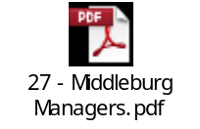

  - Laramie Demographics
The PDF files below contain Laramie Demographic information provided by Claritas.




The top three PDFs contain overall reports of the demographic trends in Laramie. The bottom three reports contain systematically organized demographic information: the population organized by age and race, the population organized by age and sex, and the population organized by age by sex by race.

  - Population and household Trends: 2010 vs. 2015
The PDF below contains the household trends report for Laramie as seen through the 2010 census, 2015 estimates, and 2020 projections.


The report contains information on the population, housing, and income. For example, in 2010 Laramie had a population of 30,816 and in 2015 it is estimated to have a population of 32,125: an increase of 4.25%. The report projects that between 2015 and 2020 the population will increase by 4.45% and become 33,555.

There were an estimated 13,366 households in Laramie in 2010 and 14,118 in 2015, an increase of 5.63%. The rate of increase in projected to decline to 5.33% with the number of households in 2020 projected to be 14,870.

The report also offers information on income. The average household income in 2000 was $37,593, which increased to $58,732 in 2015 and is projected to have increased to $64,705 by 2020.

  - Laramie Unique Retailers
The excel file below contains a list of retailers in Laramie Wyoming that are listed as a single location-privately held company. This list was created using Reference USA.

The file contains two tabs; the first tab “5 to 250 Employees” contains a list of 137 retailers in Laramie with between five to 250 employees. The second tab “1 to 4” contains a list of 183 retailers in Laramie with between one and four employees.


The second excel file below contains a list of 51 restaurants unique to Laramie found through Reference USA.



  - Competition: Cheyenne & Fort Collins Markets
The PDF files below contain the Retail Marketplace Reports for Cheyenne and Fort Collins.

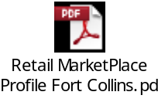
These reports contain information on the demand (retail potential) and supply (retail sales) for different industries in the cities. For Cheyenne, there is a surplus for almost every industry aside from Lawn & Garden Equipment & Supply Stores, Furniture Stores, Direct Selling Establishments, and Special Food Services.

The Fort Collins retail market is heavily over saturated in the in the Food & Drink industries, but there is a retail gap in many other industries.

- Retail Data
  - Retail Marketplace Profile: Albany, Laramie, and University Campus
The three PDF files below contain the retail marketplace profiles for Albany County, Laramie, and the University of Wyoming Campus.



The Albany County Market as well as the Laramie Market is experiencing a retail gap in the Furniture & Home Furnishings Industry. Also, both markets are experiencing a gap in the Clothing & Clothing Accessories market.

The market for the University Of Wyoming Campus is under met in every industry aside from Book, Periodical, and Music Stores. This is a result of the University Book Store being the most profitable business in Laramie.

  - Laramie Consumer Spending Reports: 2015 and 2020
In the PDF files below are the estimated consumer expenditure for 2015 and the projected consumer expenditure for 2020 for eight different industries.



The total estimated consumer expenditure for Laramie in 2015 is $746,333,000 and the projected amount for 2020 is $809,905,000.

  - Cheyenne Consumer Spending Reports: 2015 and 2020
In the PDF files below are the estimated consumer expenditure for 2015 and the projected consumer expenditure for 2020 for eight different industries.

The total estimated consumer expenditure for Laramie in 2015 is $1,421,327,000 and the projected amount for 2020 is $1,577,441,000.

  - Fort Collins Consumer Spending Reports: 2015 and 2020
In the PDF files below are the estimated consumer expenditure for 2015 and the projected consumer expenditure for 2020 for eight different industries.

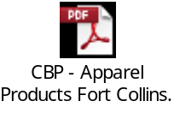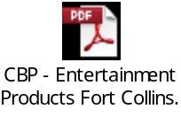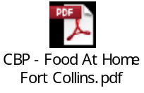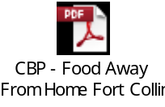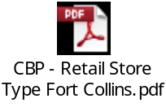

The total estimated consumer expenditure for Laramie in 2015 is $3,610,126,000 and the projected amount for 2020 is $3,964,829,000.

  - Retail Sectors where Laramie has Competitive Advantage: Tourism
Laramie offers an abundance of products and services unmatched by every other Wyoming town, but Laramie’s entire competitive advantage lies within the University.

The University related sporting events bring a large amount of tourists to Laramie. Laramie also accommodates a large tourist population during graduation weekend of the University.

Laramie also offers a unique experience with nature. Vedauwoo is a popular climbing destination.

(If you cannot open a PDF document, open Adobe Reader or Acrobat, select Edit-Preferences-General for Reader or Edit-Preferences-Security (Enhanced) for Acrobat and make sure that Protected view or mode is turned off. If you are running Office for Mac or Word for Mac, the ability to open embedded PDF’s is not a part of your program. In this case, please email the MRC and we will send you the PDF’s separately.

WE NEED YOUR FEEDBACK – We are required to monitor the success of our program in order to guarantee continued funding for the Market Research Center. Please take our short survey by clicking the link below. Thank you.

https://survey.uwyo.edu/TakeSurvey.aspx?SurveyID=96K06ol02
Note: Hold down the CTRL key when clicking the link, or copy and paste the address into your browser.

“What Demographics and Psychographics Mean for Small Business Marketing”, All Business (www.allbusiness.com). http://www.allbusiness.com/marketing/market-research/426-1.html

