Louisville Metro Police Department
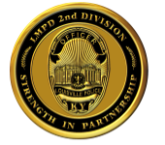
2nd Division
Meet the Beat Officer Event
Hosted by: Major Russell Miller

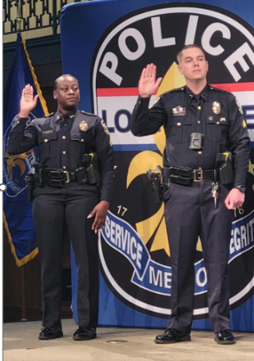
WHEN:
Wednesday Sept. 24th, 2025 Special Guest
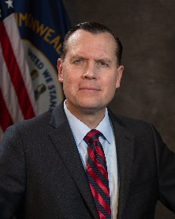
WHERE: Attorney General
Corner of Hope Church
1809 Standard Avenue
TIME:
6:00 PM to 8:00PM
Russell Coleman
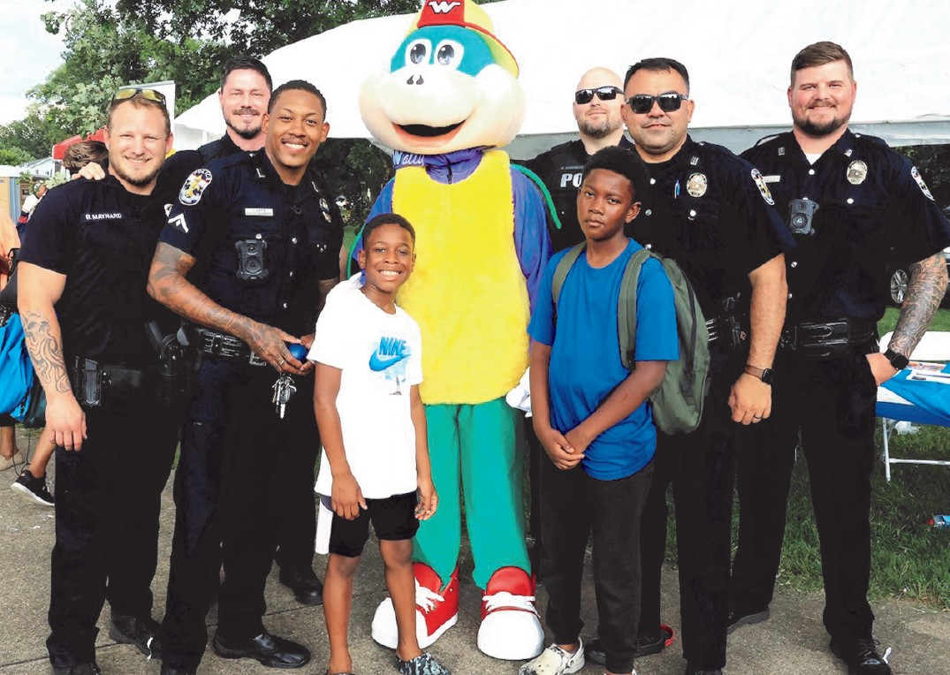
Come join 2nd Division Command Staff, Patrol Officers who ride your neighborhood & Advisory Board for a time of questions and fellowship. Our Detectives, District Resource Officers & other units will be on hand to address your questions or concerns. Refreshments Served as well!

