
Southbridge PARC grant aplication
Skatepark high level concept
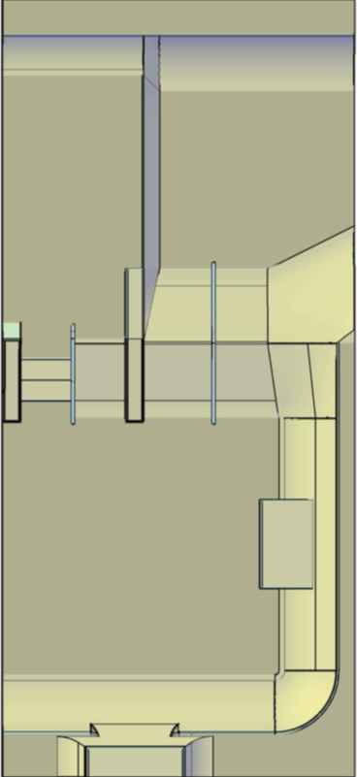
Provided by Rampage
Existing pavement is approx. 150 X 65. Reduce skatepark layout by half to approx. 70 x 30 to move the layout away from an existing embankment and replace/ redesign the fence and create shaded seating on the pavement.

