GENERAL PROVISIONS
Article 1

General Provisions

Sections:
1.01 Title.
1.02 Effective Date
1.03 Purpose.
1.04 Conformance with master plan.
.
1.05 Interpretation, conflict and severability.
1.06 Saving provision.
1.07 Effects of this title on development permit.
1.08 Interpretation of language.

1.09 Right to farm.
1.10 Aircraft Operations Rights (reserved)
1.11 Enforcement authority.
1.12 Appeals (reserved)
1.13 Land Use Definitions
1.14 Measurements, Construction, and Code Definitions

1.01 Title
This title shall be known and may be cited in all proceedings as the “Douglas County Development Code”.

1.02 Effective Date
This title, adopted to implement the Douglas County Master Plan, became effective on xxxxxx, xx, xxxx. (Ordinance XX-XXX).

1.03 Purpose.
The board of county commissioners declares that this title is adopted to promote public welfare by ensuring health, safety,and convenience; reducing traffic congestion; preserving historic and communitycharacter by providing light and air for buildings; protecting property values; preventing overcrowding ; and to supporting essential infrastructure and services. It aims to achieve economic and social benefits through comprehensive land use planning. This title has been combined into one ordinance for the purpose of maintaining consistency, shortening the overall length of the document, and to improve user-friendliness for the end users.

1.04 Conformance with master plan.
This title and the official zoning map of the county, as adopted, are declared to conform to the master plan of the county pursuant to the provisions of chapter 278, NRS.

1.05 Interpretation, conflict and severability.
- In their interpretation and application, the provisions of this title shall be held to be the minimum requirements for the promotion of the public health, safety, morals, convenience and general welfare. These regulations shall be construed broadly to promote the purposes for which they are adopted.
  - Public provisions. These regulations are not intended to interfere with, abrogate, or annul any other ordinance, rule or regulation, statute or other provision of law except as provided in these regulations. Where any provision of these regulations imposes restrictions different from those imposed by any other ordinance, rule or regulation of the county, or other provision of law, the provision which is more restrictive or imposes higher standards shall control.
  - Private provisions. Private easements, covenants, conditions and restrictions of record are not enforced by the county except as specifically provided by agreement of Douglas County
- If any part or provision of these regulations or the application of these regulations to any person or circumstances is adjudged invalid by any court of competent jurisdiction, the judgment shall be confined in its operation to the part, provision, or application directly involved in the controversy in which the judgment shall be rendered and it shall not affect or impair the validity of the remainder of these regulations or the application of them to other persons or circumstances. The board hereby declares that it would have enacted the remainder of these regulations even without any such part, provision, or application which is judged to be invalid.

1.06 Saving provision.
The provisions of this title shall not be construed as abating any action now pending under, or by virtue of, prior existing land development regulations, or as discontinuing, abating, modifying, or altering any penalty accruing or about to accrue, or as affecting the liability of any person, firm, or corporation, or as waiving any right of the County under any chapter or provision existing at the time of adoption of these regulations, or as vacating or annulling any rights obtained by any person, firm, or corporation, by lawful action of the county except as shall be expressly provided for in these regulations.
The provisions of this title notwithstanding, in the Lake Tahoe Basin every structure housing gaming under a nonrestricted license which existed as a licensed gaming establishment on May 4, 1979, or whose construction was approved by the Tahoe Regional Planning Agency (TRPA) affirmatively or deemed approved before that date is recognized as a permitted and conforming use and as complying with and conforming to all of the regulations prescribed in this title. Any existing or approved structure and associated structures may be repaired, reconstructed, altered and rebuilt or replaced in whole or in part to a size in accordance with the Tahoe Regional Planning Compact.
Alteration, rebuilding or replacement shall, if required, comply with the provisions of this title including applicable building, mechanical, plumbing, electrical and fire codes.

1.07 Effect of this title on development permits.
- Approved development.
  - Development to which an application for design review, special use permit, variance, tentative parcel map, final parcel map, tentative subdivision map, final subdivision map, tentative land division map or final land division map has been finally approved and which approval remains valid on the effective date of this title shall remain valid unless such approval expires by the terms of the approval or in accordance with chapter 20.30. Development which has been granted approval may be built in accordance with the development standards in effect at the time of approval, provided that the approval is valid at the time building permits are issued and that the approval is subject to any time limits imposed pursuant to this title; further provided that any subsequent applications for a development permit required by this title prior to issuance of and including a building permit and certificate of occupancy shall be processed in accordance with the procedures established by this title for the processing of such development permit.
  - No provision of this title shall require any change in the plans, permit expiration, construction or designated use of any structure for which a building permit has been issued prior to the effective date of this title or any subsequent amendment.
  - Any reapplication for an expired development permit must meet the standards in effect at the time of reapplication.
- Projects in process. Development for which an application for a development permit has been accepted as complete, but which has not been granted final approval by the appropriate designated official prior to the effective date of this title, shall be subject to the land use regulations, standards for approval, and other requirements in effect at the time the application was deemed complete; provided that any subsequent application for a development permit required by this title prior to issuance of and including a building permit and certificate of occupancy shall be processed in accordance with the procedures established by this title for the processing of such development permit. If approved, the development may be built in accordance with the development standards in effect at the time of application, provided that any design review filed subsequent to the issuance of a special use permit or reapplication for an expired permit must meet the standards for approval in effect at the time of application. This provision shall not apply to any application for a master plan amendment or zoning map amendment.New applications. If no application for a development permit has been accepted as complete and the development has received no more than approval of a master plan map amendment or a zoning map amendment prior to the effective date of this title, pending and subsequent applications for development approval shall be subject to all requirements, standards and procedures set forth in this title.
1989)
1.08 Interpretation of language.
In the event this title requires interpretation, the director may make the interpretation or refer the matter to the planning commission for action, except as otherwise provided.)
NOTE: Moved to Article 7: Applications and Procedures

1.09 Right to farm.
It is the declared policy of Douglas County to conserve, protect, enhance, and encourage agricultural operations within the county. Further, it is the intent of the county to provide proper notification of the county’s recognition of agriculture’s right to farm.
Where non-agricultural land uses, and especially residential developments, extend into agricultural areas or exist side-by-side, agricultural operations have often become the subject of nuisance complaints. As a result, agricultural operations are sometimes forced to cease or curtail operations and many others are discouraged from making investments in farm improvements to the detriment of adjacent agricultural uses and economic viability of the county’s agricultural industry as a whole. It is the purpose of this chapter to protect agricultural resources and to reduce the loss to the county’s agricultural lands by limiting the circumstances under which agricultural operations may be considered a nuisance. This chapter is not to be construed as in any way modifying or abridging any provision of NRS relative to nuisances, but rather is only to be utilized in the interpretation and enforcement of the provisions of this code and county regulations.
The further purpose of this code section is to promote a good neighbor policy between farmers, ranchers and residents by advising purchasers and users of property adjacent to or near agricultural operations of the inherent potential problems associated with proximity to agricultural operations, including but not limited to the sounds, odors, dust and chemicals that may accompany agricultural operations so that these purchasers and users will understand the inconveniences that accompany living side-by- side with agricultural uses and will be prepared to accept the problems as the natural result of living in or near rural areas.The right to farm purposes shall be furthered through the following:
- No existing or future agricultural operation or any of its appurtenances conducted in a manner consistent with proper and accepted standards on agricultural land shall become or be a nuisance, for purposes of all chapters of this code, provided that the agricultural operation complies with all chapters of this code and provided that the provisions of this section shall not apply whenever a nuisance results from the negligent or improper operation of any agricultural operation.
- Douglas County shall cause to be mailed to all property owners of real property within the county with the annual tax bill the following notice: “Douglas County has declared it a policy to protect and encourage agricultural operations. If your property is located near an agricultural operation, you may at some time be subject to inconvenience or discomfort arising from agricultural operations. If conducted in a manner consistent with proper and accepted standards, these inconveniences and discomforts do not constitute a nuisance for purposes of the Douglas County Code.”
- When giving notice required by NRS, a person who is selling real property which is near an agricultural operation shall disclose in writing to the prospective purchaser the notice contained in paragraph B above.
- Where a discretionary development permit, including but not limited to subdivision and special use permit, is sought on or adjacent to lands zoned to permit agricultural operations, the discretionary permit shall include a condition requiring the recordation of a deed restriction to notify any present or future owners, users and tenants of the notice contained in paragraph B above.
- The county may require the developer to install or permit the installation of signs to notify prospective purchasers and users that adjacent or nearby lands are being used for agricultural purposes and that those interests are protected by law.)

1.10 Aircraft Operation Rights (reserved)
1.11 Enforcement authority.
- It is the duty of the director or his authorized representative to enforce all of the provisions of this chapter.
- It is unlawful for any person to interfere with the director or his authorized representative in the performance of his duties.)
1.12 Appeals (reserved)

PROCEDURES COMMON TO PLANNING, ZONING, AND LAND DIVISION REGULATIONS
NOTE: This entire chapter was moved to Article 7: Applications and Procedures

Application Process and Official Filing Date NOTE: This entire chapter was moved to Article 7: Applications and Procedures

Sections: NOTE: This entire chapter was moved to Article 7: Applications and Procedures

Sections: NOTE: This entire chapter was moved to Article 7: Applications and Procedures

NOTE: This entire chapter was moved to Article 7: Applications and Procedures

NOTE: This entire chapter was moved to Article 7: Applications and Procedures

NOTE: This entire chapter was moved to Article 7: Applications and Procedures

(Ord. 763, 1996)

Sections: NOTE: This entire chapter was moved to Article 7: Applications and Procedures

Chapter 20.24 Public Hearing Procedures
Sections: NOTE: This entire chapter was moved to Article 7: Applications and Procedures

Chapter 20.28
Post Decision Proceedings

Sections: NOTE: This entire chapter was moved to Article 7: Applications and Procedures

Sections: NOTE: This entire chapter was moved to Article 7: Applications and Procedures

Sections: NOTE: This entire chapter was moved to Article 7: Applications and Procedures

Chapter 20.34 Enforcement
Sections: NOTE: This entire chapter was moved to Article 7: Applications and Procedures

Chapter 20.38 Board of Adjustment
Sections: NOTE: This entire chapter was moved to Article 7: Applications and Procedures

Sections: NOTE: This entire chapter was moved to Article 7: Applications and Procedures

Chapter 20.44 Rounding of Quantities

NOTE: This entire chapter was moved to Article 7: Applications and Procedures

AGREEMENTS
Chapter 20.400

Development Agreements
Sections: NOTE: This entire chapter was moved to Article 7: Applications and Procedures

Chapter 20.440
Density Bonus and Affordable Housing Agreements

Sections: NOTE: This chapter was moved to Article 2 - Growth Management, Transfer, and Allocation of Development Rights

Chapter 20.460 Reimbursement Agreements
Sections: NOTE: This chapter was moved to Article 7 - Applications and Procedures

Chapter 20.470 Maintenance Districts
Sections NOTE: This chapter was moved to Article 7 - Applications and Procedures

Chapter 20.471 Maintenance District 1 – Monterra
Sections NOTE: This chapter was moved to XXXXX

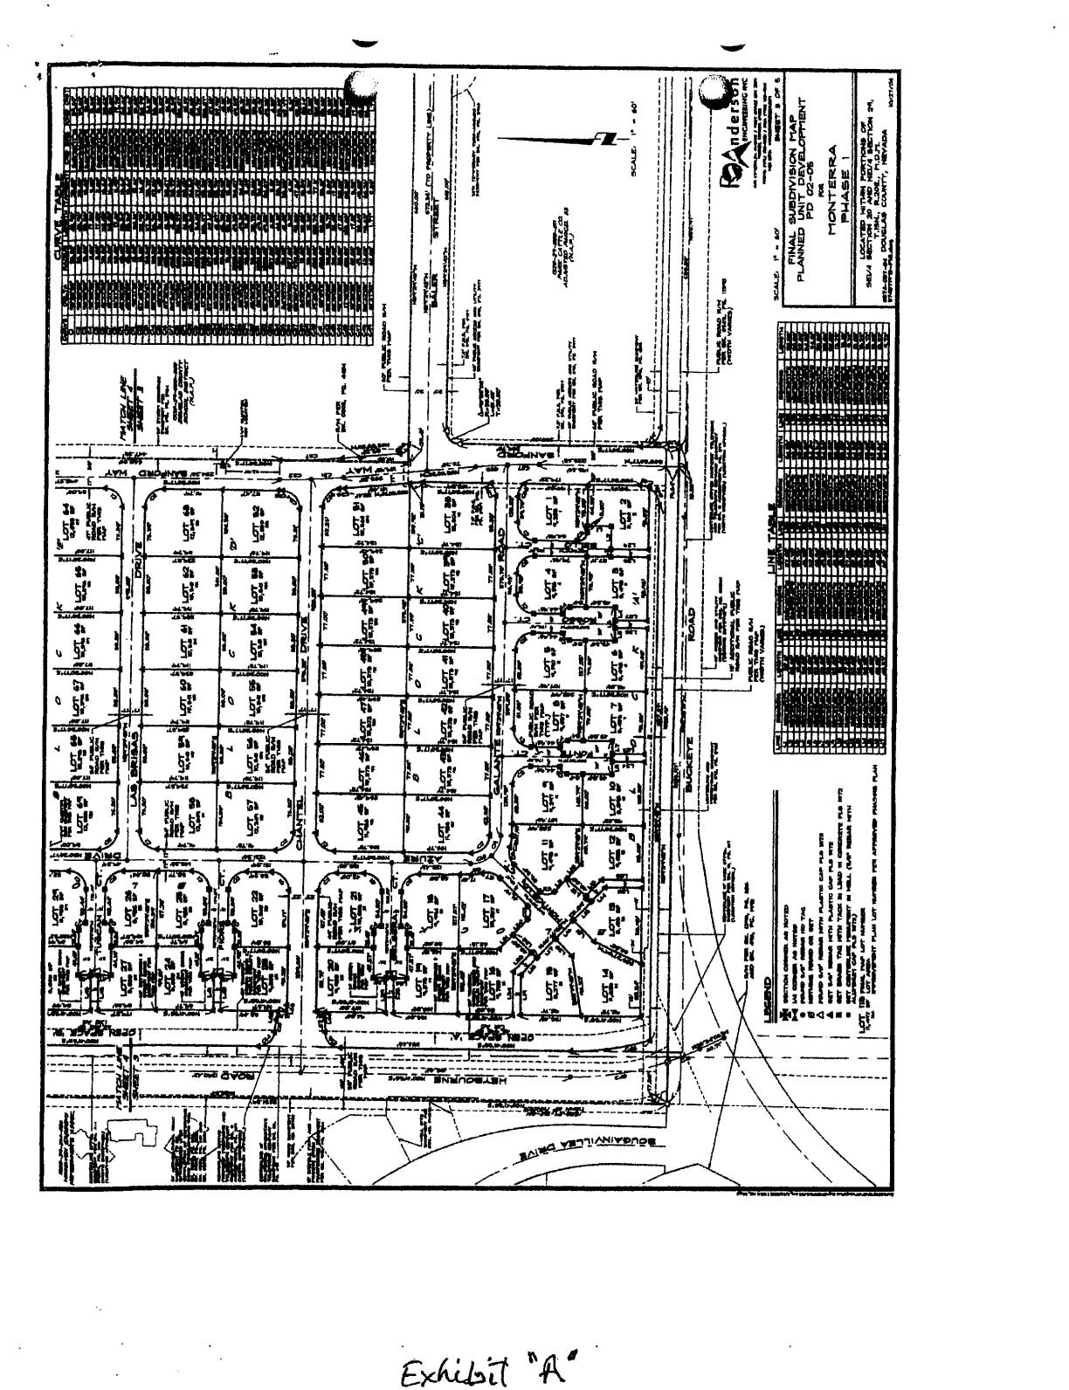

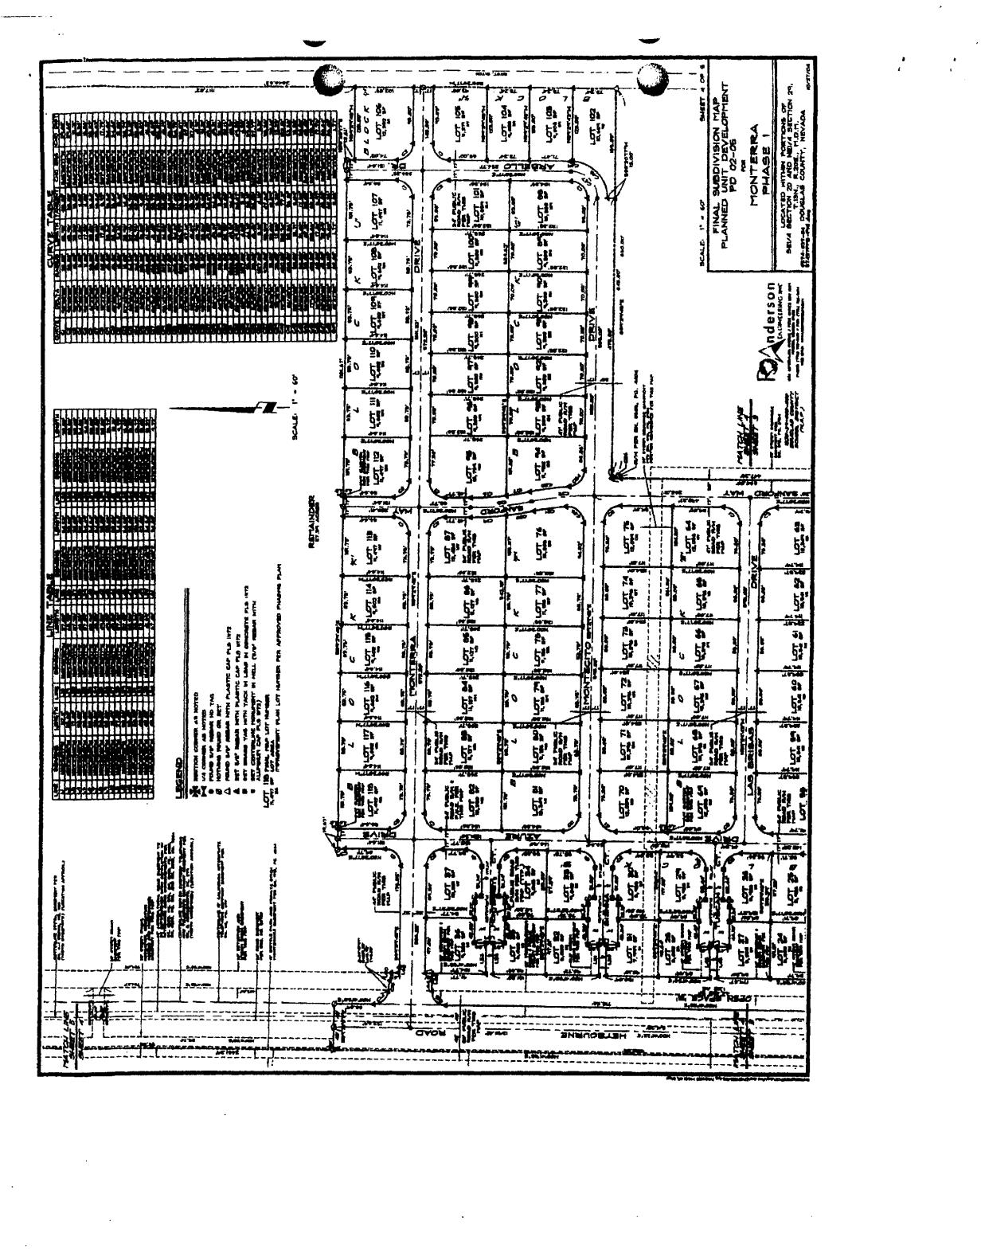

- --

j_ MONTERRA
_.I
- -·-------•·· -----·---

- ·•••·•-

- --.

LMAD DISCLOSURE STATUS
- - - :-==-=- 1/9/2014-===-- --=-------------
- -·-··--·- -
----·-·---- ------- -- ----
-------- ---------

LOT
··••···#- - c-·-- ADDRESS --

APN
CLOSING
c-- PURCHASER-- f--oi\t1:r-- --UiAO? --

-·•-·--
---- - 1 1705 Bello Court
2 - 1703 Bello Court

·- -·-·

1320-29-610-001
1320-29-610-002

-- And Away They Go--
-6/29i12 6/29112
----
_y _s_

----- "3 -- -
-- 1320-29-610-003
And Away T _ .£
- 6/29/12 --
_y s

-- .. .. --- 1703 Rosso Court
_45 1705 Rosso Court ..
And_AwayThef Go_
- ·--1320-29-610.()()4 -- And Away They Go

6/29/12
yes_ yes

----6
1704 Rosso Court
1320-29-610-005
H&S Construction
1/17/14
yes

- -y ---· 1702 Rosso Court ------
1320-29-610-006
H&S Construction
1/17/14
i'. ---

--8 -
1703 Fonte Court --·
1320-29-610-007
H&S Construction
1/17/14
yes

1705 Fonte Court
- -9- - -
1704 Fonte Court
-· 1320-29-610-008
1320-29--610-009
H&S Construction
- - H&S Construction
1/17/14
·-:;-r,7714-
--
yes
_y_e ----

10 •
1702 Fonte Court | 1320-29-610-010 | H&S Construction | 1/17/14 | ves
1707 Monticello Court -- | 1320-29-610-011 | H&S Construction | 1/17/14 | yes
 | 1320-29-610-012 | H&S Construction | 1/17/14 | yes
1703 Monticello Court | 1320-29-610-013 | And Away Thev Go | 6/29/12 | yes
•---  1702 Monticello Court | -  1320-29-610-014 | And Away They Go | 6/29/12 | yes

----
----1121 -
fa
··1-f
15

·- 1705 Monticello Court ---

--- 16
1704 Monticello Court  1706 Monticello Court | 1320-29-610-015 -  1320-29-610-016 | And Away They Go  And Away They Go | 6/29/12  6/29/12 | yes  yes
1708 Monticello Court | 1320-29-610-017 | And Awav Thev Go | 6/29/12 | yes
1107 Belsera Court | 1320-29-610-018 | And Away They Go | 6/29/12 | yes

17

f --.,8
--·jg
··--·
20

1105 Belsera Court --
1106 Chantel Drive
1320-29-610-019 | ABN Enterprises | 11/1/13 | yes
1320-29-610-035 | And Awav They Go | 6/29/12 | yes
1320-29-610-034 | And Away They Go | 6/29/12 | ves

----------- 110-8Chantel Drive >---
21
--··
2232 | 1107 Fiore Court 1320-29-610-048  1105 Fiore Court 1320-29-610-049 |  | Kyle  Walmsely | 9/12/13  12/10/13 | yes  yes
24 | 1106 Fiore Court | 1320-29-610-050 | Gart | 817/13 | oending

- -·-25
1108 Fiore Court | 1320-29-610-051 | Lawver | 10/17/13 | ves
1107 Tuscan Court | 1320-29-610-052 | Clifton | 10/29/13 | yes

---
26

- 29--
27 | 1105 Tuscan Court | 1320-29-610-053 | Vanderlaan | 9/10/13 | pendinq
28 | 1106 Tuscan Court | 1320-29-610-054 | Xu | 3123/11 | no
 | 1108 Tuscan Court | 1320-29-610-055 | Stack | 7/16/12 | yes
30 | 1107 Sienna Court | 1320-29-610-068 | Chaney | 7/16/13 | pending_
31 | 1105 Sienna Court | 1320-29-610-069 | Shrader | 7/26/13 | oending
32 | 1106 Sienna Court | 1320-29-610-070 | Dobson/Roussakis | 3/19/13 | oendinq
33 | 1108 Sienna Court | 1320-29-610-071 | Myers | 3/18/13 | yes
34 | 1107 Monterrey Court | 1320-29-610-073 | Pitts | 3/16/12 | ves
35 | 1105 Monterrev Court | 1320-29-610-072 | James Tomales Trust | 3/28/13 | yes
36 | 1106 Monterrey Court | 1320-29-510-016 | And Awav They Go | 6/29/12 | yes
37 | 1108 Monterrey Court | 1320-29-510-015 | And Away They Go | 6/29/12 | ves
38 | 1124 Galante Road | 1320-29-610-026 | And Away They Go | 6/29/12 | yes
39 | 1122 Galante Road | 1320-29-610-025 | And Awav Thev Go | 6/29/12 | ves
40 | 1120 Galante Road | 1320-29-610-024 | And Away They Go | 6/29/12 | ves
41 | 1118 Galante Road | 1320-29-610-023 | H&S Construction | 1/17/14 | yes
42 | 1116 Galante Road | 1320-26--610-022 | H&S Construction | 1/17/14 | ves
43 | 1114 Galante Road | 1320-29-610-021 | H&S Construction | 1117/14 | yes
44 | 1112 Galante Road | 1320-29-610-020 | H&S Construction | 1/17/14 | yes
45 | 1111 Chantel Drive | 1320-29-610-033 | H&S Construction | 1/17/14 | ves
46 | 1113 Chantel Drive | 1320-29-610-032 | H&S Construction | 1/17/14 | yes
47 | 1115 Chantel Drive | 1320-29-610-031 | H&S Construction | 1/17/14 | ves
48 | 1117 Chantel Drive | 1320-29-610-030 | H&S Construction | 1/17/14 | yes
49 | 1119 Chantel Drive | 1320-29-610-029 | H&S Construction | 1/17/14 | yes
50 | 1121 Chantel Drive | 1320-29-610-028 | H&S Construcbon | 1117114 | ves
51 | 1123 Chantel Drive | 1320-29-610-027 | H&S Construction | 1/17/14 | yes
52 | 1122 Chantel Drive | 1320-29-610-041 | And Away Thev Go | 6/29/12 | yes
53 | 1120 Chantel Drive | 1320-29-610-040 | And Awav They Go | 6129/12 | yes
54 | 1118 Chantel Drive | 1320-29-610-039 | And Away They Go | 6/29/12 | yes
55 | 1116 Chantel Drive | 1320-29-610-038 | And Awav Thev Go | 6/29/12 | yes
56 | 1114 Chantel Drive | 1320-29-610-037 | And Away They Go | 6/29/12 | yes
57 | 1112 Chantel Drive | 1320-29-610-036 | And Away They Go | 6129112 | yes
58 | 1111 Las Brisas Drive | 1320-29-610-047 | And Away They Go | 6/29/12 | ves
59 | 1113 Las Brisas Drive | 1320-29-610-046 | And Away Thev Go | 6/29/12 | ves

--
--

- - -

--

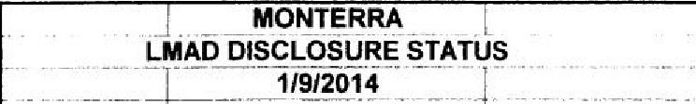

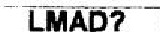
-

LOT CLOSING
---- -# -- ----- ADDRESS •• ••• • - APiii" ... -- ····-· PURCHASER - -DATE-
60 1115 Las Brisas Drive 1320-29--610-045 And ll:_ tlfJy_9cc--o +---:6 /2:c:9c-c/-:-c12c-+--- v,e_s_--l
6f- "f117 Las Brisas Drive----· -1320-29-610-044 And Away They Go 6/29/12 ves
}• - ; ::: =
-----62 1119 Las Brisas Cirive·--· ·--f320·29 -10-043-·- And Away They Go 6/29/12 yes
g =- - • i;; ¾ r+- ; s i no - {+!- ---- -::-:--,
• - • 65 11261-as Brisas Drive •• ·--1320-29-610-060 H&S Construction 1/17/14 yes
I
66 1118 Las Brisa_s_D_!'._i .. -:J320-29--610-059-- H&S Construction 1/17/14 yes
------67 1116 Las Bnsas Dnve 1320-29-610-058 H&S Construction 1/17'/01-c-4 ,---v-ie_s_--,
---68 1114 Las Blisas Olive 1320-29-610-057 H&S Construction -- H4c--+--- v1e s --1
69 --·· f112Tas Blisas Drive • - • 1320-29--610-056- H&S Co-n·s·t-ru-c-ti-on--+---1-,1-7-/1•(- yes
-- --'Hf.- • 1111 Montecito Drive | 1320-29--610-067 ---H&S Construction | 1/17/14 | yes
71 1113 Montecito Drive | 1320-29·610·066 H&S Construction | 1/17/14 | yes
----72 1115 Montecito Drive 1320-29-610-065 H&S Construction 1117/14 yes
-- · _1:f 1117 Montecito Drive••-··1 1320-29-610-064 H&S Construction 1i17/14 yes
--··· 74 -1119Montecito Drive • 1320-29-610-063 ·---H&s·construction -+--1cc1-cc17"'1,,-14--c---+-- v,esc_---,
-- 75 1121 Montecito Drive- =--- 1320-29-610-062 ·- And Away They Go 6/29/12 yes
76 1122 Montecito Drive 1320-29-610-079 And AwavThev Go 6/29/12 yes
- ·-77 1120 Montecito Drive ··1320-29-610-078 Peqram Trust 6/29/12 yes
  - 78- • 1118 Montecito Drive 1320-29-610-077 And Away They Go 6/29/12 yes
-79 11116 Montectto Drive 1320-29-610-076 And AwaY..!llfJy_G=_o ,_6 /2 9 / 12 +--y e_s_--, 11114 Montecito Drive _I_
::_:: 9- ..
·1
1320-29-610-07 -- | <:!_ a_y_ They Go |  | 6/29/12 yes
1320-29-610-074 | And Away They Go |  | 6/29/12 yes

B1 11112 Montecito Drive
82 1111 MonterraDrive 1320-29-510-014 _AndAw hevGo 6/29/12 yes
·-63 1113MonterraDrive 1320-29-510-013-- - AndAwavThevGo 6/29112 yes 1..!_1§Monterra Drive
-= i
--- ----- |  | 1320-29-510·012 |  | And Away They Go | 6/29/12 | ves
85 | 1117 Monterra Drive | 1320-29-510-011 |  | And Awav They Go | 6/29/12 | yes
: 86--· | 1119Monterra- - | 1320-29-510-010 |  | Sorbet | 7/16112 | yes
. 87 | 1121 Monterra Drive | 1320-29-510-009 | -· | Sorbet | 7 1 1 61 1 2 | ves
88 | 11138 Montecito Drive | 1320-29-610-086 |  | Sorbet | 7 1 16 1 1 2 | yes

•••• 89 11136 Montecito Drive-·· 1320-29-610-085 ·---;::S-or⁷b-e.,---t----i--c7cc/cc-16'-"'/,,.12=--+-- yes---t
-- -1134 Montecito Drive 1320-29-610-084 Sorbet·- 7/16/12 yes
--·91 1132 Montecito Drive 1320-29-610-083 Sorbet 7/16/12 yes
---· 92· 1130 Montecito Drive --- 1320-29-610-082 Reshaw 12/8/10 yes
93 112B Montecito Drive 1320-29-610-081 Allbri11ht 5/21/10 ves

94 1126 Montecito Drive I 1320-29-610-080
95 1127 Monterra Drive l 1320-29-510-008
96 1129 Monterra Olive 1320-29-510-007
97 1131 Monterra Drive 1 1320-29-510-006
98 1133 Monterra Drive 1320-29-510-005
99 1135 Monterra Drive 1320-29-510-004
Ewbank Harrison Kenison Leiss Paine Shorten
11/30/07 yes
3/30/12 yes
7/1/13 no
B/1/13 ves
10/24/13 yes
11/4/13 ves

100
101
102
103
104
105
1137 Monterra Drive 1320-29-510-003
1139 Monterra Drive I 1320-29-510-002
1725Arbello Drive I 1320-29-610-087
1727 Arbello Drive 1320-29-610-088
1729 Arballo Drive 1320-29-610-089
1143 Monterra Drive 1320-29-510-001
ABN Enterprises ABN Enterprises Armstrong Sorbet
Sorbet
And Awav Thev Go
11/1/13
11/1/13
3/18/11
7/16/12
7/16/12
6/29/12
yes yes yes yes yes yes

106
107
108
109
110
1140 Monterra Drive I 1320-29-510-029
1138 Monterra Drive 1320-29-510-028
1134 Monterra Drive 1320-29-510-027
1132 Monterra Drive 1320-29-510-026
1130 Monterra Drive 1320-29-510-025
And Awav Thev Go 6/29/12 Mackinen 1 8/19/08
Whitaker 8/29/11
Kesteloot 11/20/09
Fond 6/28/12
yes ves yes yes ves

111 !1128 Monterra Drive , 1320-29-510-024
Torres/Bias 12/B/11
yes

112 1126 Monterra Drive 1320-29-510-023
Brower
9/13/12 no

- 1122 Monterra Drive
- 1120 Monterra Drive
- 1118 Monterra Drive
1320-29-510-022
1320-29·510-021
1320-29-510-020
Jantos HanIv Pumphrey
5/2/12
6/29/12
8/18/09
yes yes yes

- 11116 Monterra Drive
- 1114MonterraDrive
1320-29-510-019
1320-29-510-018
Buttlar Nemcik
7/24/09 1 yes
7/27/11 no

- l1112MonterraDrive
i
1320-29-510-017 1 Dedmon
118
3/29/12 ves

- -

DESCRIPTION MONTERRA PHASE 1 OPEN SPACE
0574-037-0il
02120101
!
Page 1 of 11

All that real property situate in the County of Douglas, State of Nevada, described as follows:
i
'Open Space Lots 'A' and 'B' as shown on the Final Subdivision Map for Monterra Phase 1 recorded August 24, 2005 in the office of Recorder, Douglas County, Nevada as Document No. 653145, containing 2.03 acres, more or less.

Note: Refer this description to your title company before incorporating into any legal document.
Prepared By: R.O. ANDERSON ENGINEERING, INC.
P.O. Box 2229
Minden, Nevada 89423


  - S:\P ects 57 ·0371Leg I Descr;,nons\0574_-037MonterraOpen Spa .l!JI.




FINAL
PLANNED
SUBDIVISION MAP UNIT DEVELOPMENT PO 02-05

NIC>NTERRA.
PH·ASE '1
LOCATED WITHIN PORTIONS OF SE1/4 OF SECTION 20 AND THE NE1/4 OF SECTION 29,
TOWNSHIP 11 NORTH, RANGE 20 EAST, MOUNT DIABLO MERIDIAN DOUGLAS COUNTY, NEVADA

=,...,..= ...=.....-=----= .-,-.r.-
--..:.-"-:..... .:c :.u. -:.-- -
-/,r (

,._..Clffl'ICA,,

--=§a- ia==--=:!=­
- ...,, Cl' !Y!·P"fflffi"''llll
::=::=.-
- -"'#-'
- .
P9'ffl I'
===
'!M ,,.,.,,.,,, E!N!2ffi!

4001
-,,-;,...,_....,,..llll'tla .

9¥fP:9:ff)fPT'?ft:D

=--- 1:': --:.::a"W. -..:....
T•"•­
..... ty.^{f}.^{t} ^{m} -m,.g. fPJJ..i!,i_tD, ..,,..
.:=w = c. =

-/..A,.;t--,JAl.4lcl ..... - --
.-.-_-.-,-._- .-,.-.-,o--,----•T.._9 11.1..1WTTTT

Plff ;up,
:.,_:,.=..,._..., .._,:,_ ,-.-(#--

- ---
na-..nca, -,,r

........ .---.r, •---
...... ..
-·:l'#.
·- - --r.- ,._ •.,,_.,

'--
s:wn:l'. re fPt!9ffl fP!J"ftD
==-";-:-:=;.-,:.r•-'"-=-:.--- ,...
h,µ p
Mn-
f:!-1ifflP' ffll:f'7rt
..
_, ... TO

=,..=._,-,."..-" -.-.,-,.-_=
=-
-,.-.-,uT
•lll'!f.il•"'.-•'"-."""R.....,..J. -'; a'.,.., ,- =-

,.:-=.,- -=:'"· ,.anff'r-WllJIO,
ffl-M=Z :.=!-P=IP-O-D. - :=.:..u..-.:­
---
f-li'.;9$


-.-:.-::-,._ ,_.,._--_.:,,.·:ona
---
lttl-1 RBJDiAff '

.,,,,,.,5P'Jt5A
.. ,,......, nilftloft -
¥'NIT em- fP1IB7I
:.=n- -"= =-:Jr Wftlff
-1oft"91 ---- .....-- .......,.. ,.. .6
- tp-fk
f_la..,■..1,9.-,<.,f-...T.......,.,..,.._,.U..,,..._.
.,.,.. GTIIi

.I.J._.._.T---..-._•..-..-,.-,,.u.......c ,,..,.COiDiJa'm_,W
IJ - --LC---•-_,.....,....,_.
...-
= ..........
,,.,.,....
,::_,. (

T--.ua,ft.O.... ,,. _..
., - ........ M'TII TN: M'Aft. .,....'N'Ta , ,,!,«Iii.
'nCQlft'TWIT,,. ,. ,_ffll
=' ,££:w••nt s::
--='¾-' ;;. ••,. ,.,,••
na!Ql._...5!!!§ft::,..a.iw..t&Ql(..,..,.JS:_,-,ra,.'61 •
...JR...IJ'Q.cO:.l...rt -.DJ&to,-.i..-=---. a,- iJJ.h -
a,..a..,
Wll.l.t.O.J.S!..f_ ---.,,..n._c.,--. ,:no.

- .A....

!?!!Rr"'!ffl

. - -

· Anderson
,,n,,attl,llNCI,<

TIII_Cll',....-.,,.aa:::.T_...
------T"'I -

,._ .......
---=

7-
TITLE 20-99
(January 16, 2025)

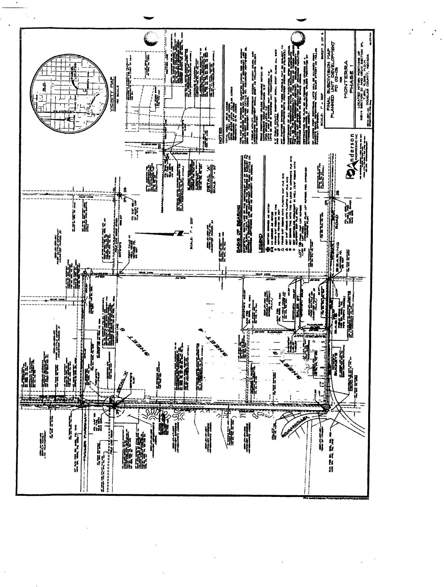

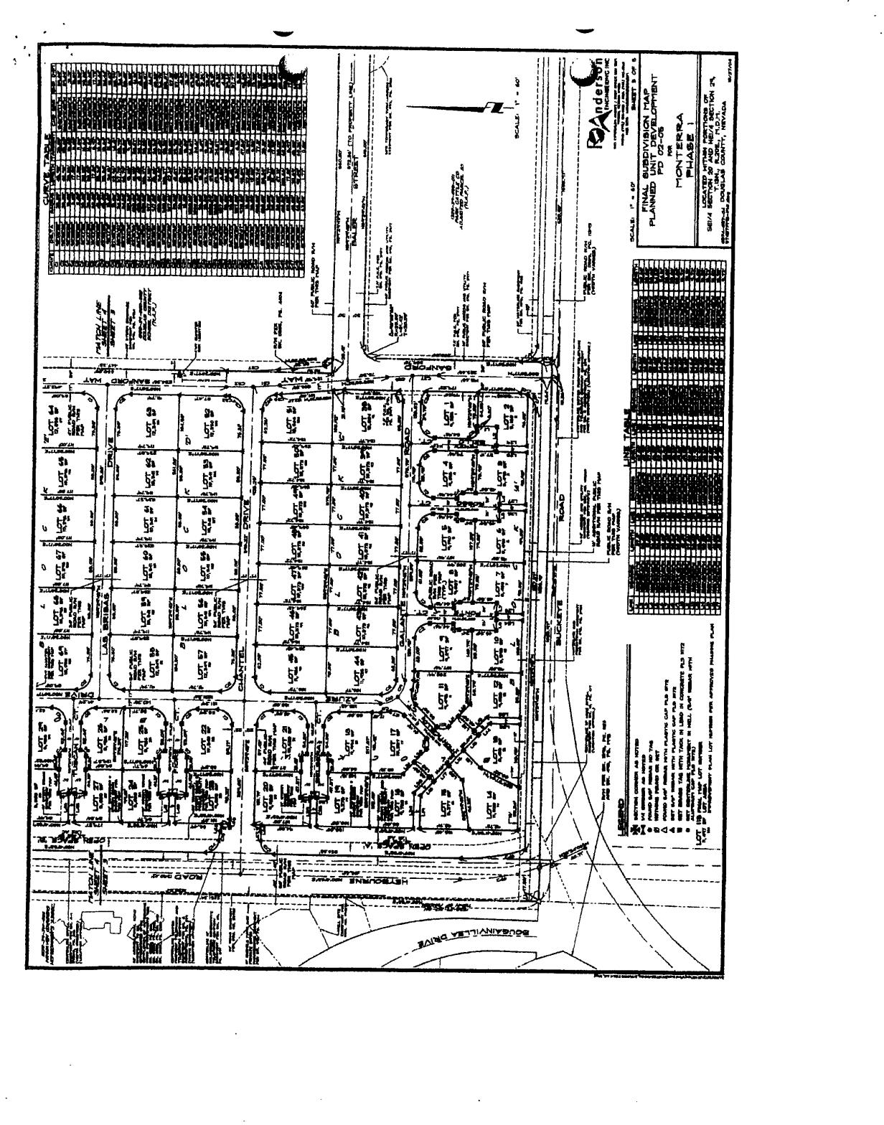

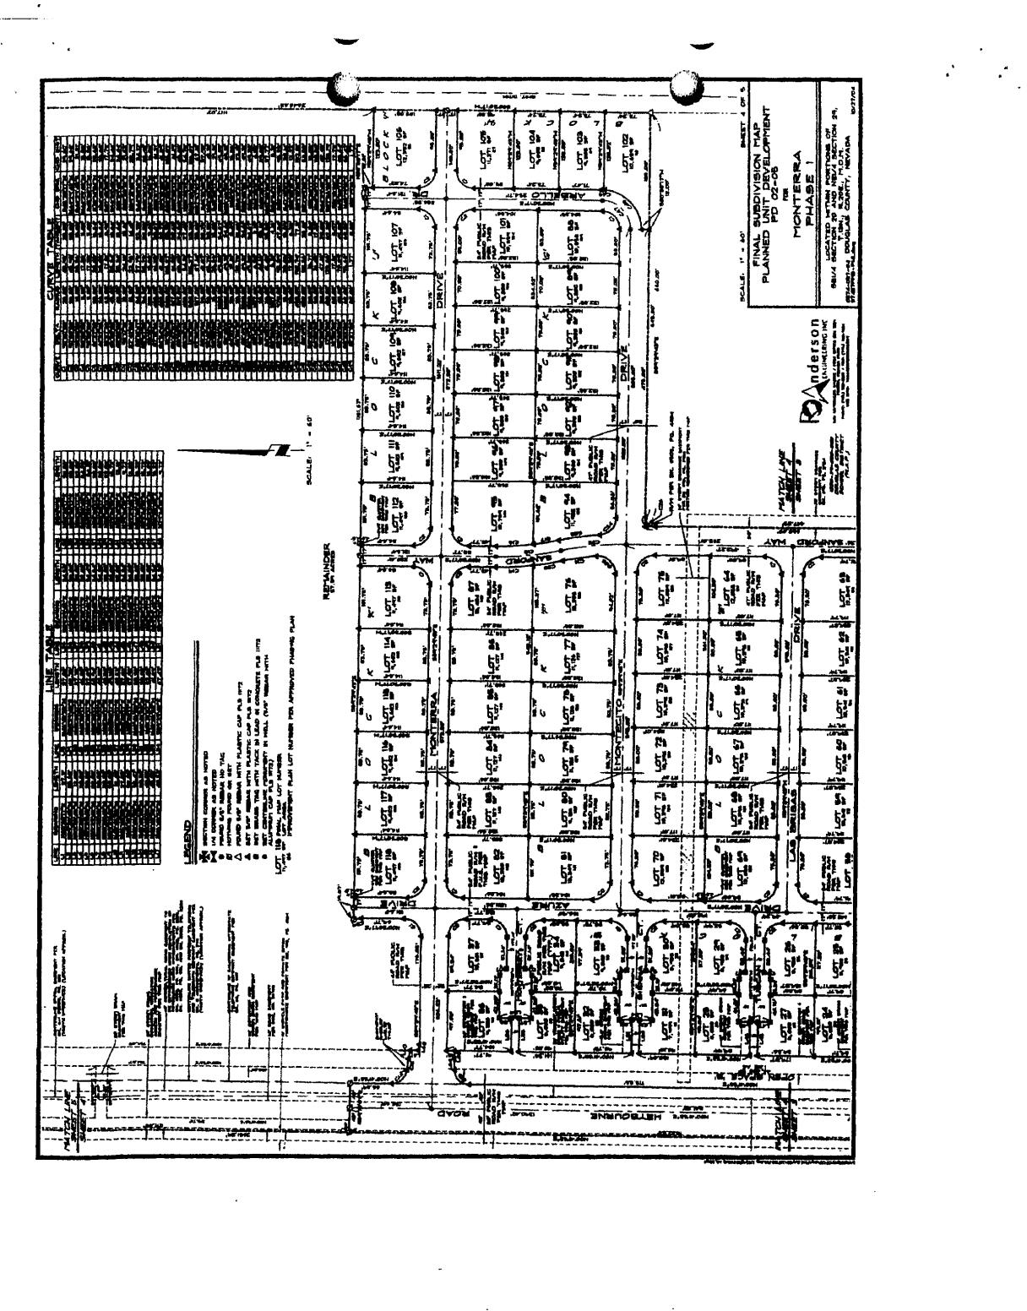

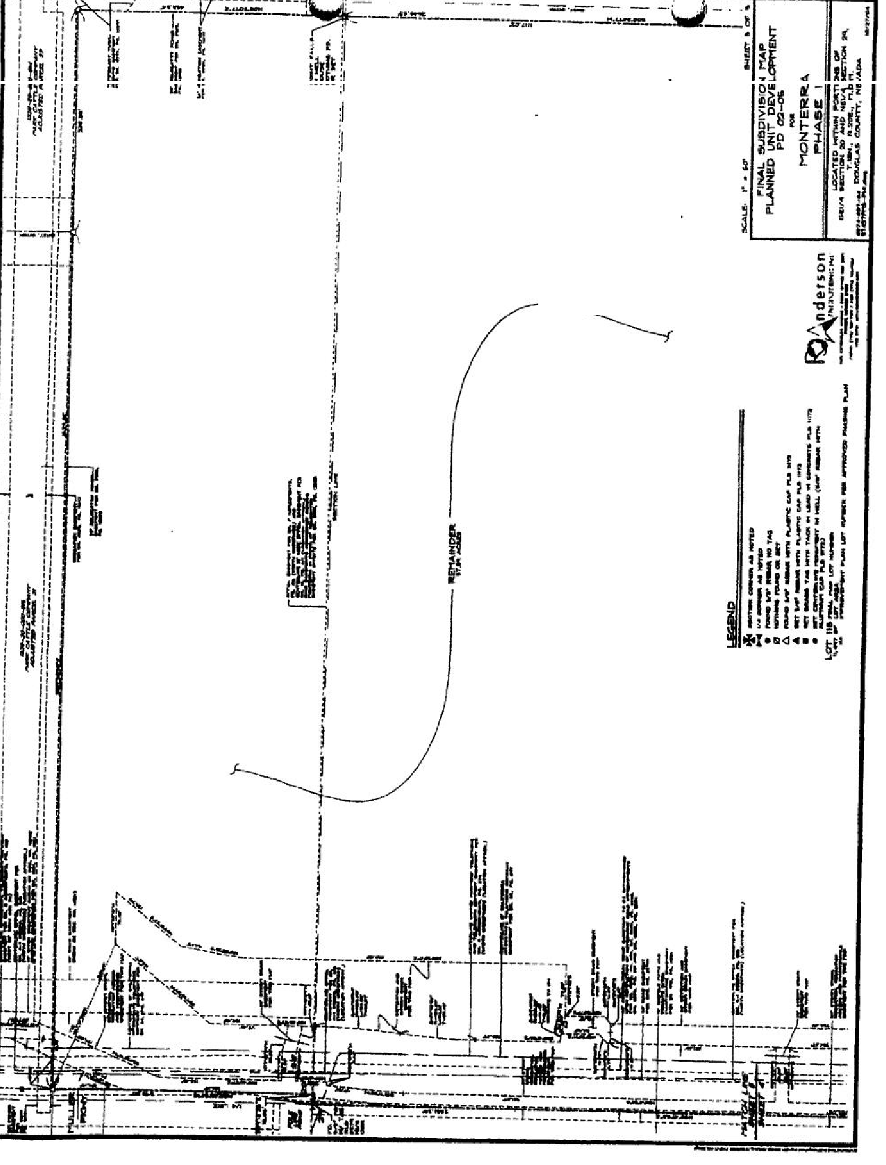
-
cz-'.
j

- -

STANDARDS FOR GROUNDS MAINTENANCE FOR
DOUGLAS COUNTY PARKS AND RECREATION

GENERAL

  - Site Checks
Site visits to pick up any loose Jitter, and check for any vandalism or irrigation problems. Done daily on regular workdays (excludes weekends and holidays) during irrigation season- weekly during non-irrigation season.
  - Debris Removal
Litter and trash including excess grass clippings, thatch, leaves, twigs, papers, bottles, cans, etc., will be properly disposed of off-site.

TURFGRASS
- Mowing
  - Turf areas will be mowed every seven days or less, May 1 through September 30, and as needed during the rest of the year.

  - Mowing heights are preferred to be in accordance with the species of turf grass as outlined below.

Bluegrass Tall Fescue

March-May June - August
September - October
approx 2"
2-1/2" 3"
approx 2"
2" 2-1/2"
2-l/2" 3"
2" 2-1/2"

  - Mowing patterns shall be alternated each week, to avoid creating ruts and compaction.

  - Whenever possible, grass clippings will not be collected, to replenish the soil with nutrients. Mulching mowers are preferred to be used. Such mowing practices recycle precious nutrients back into the soil and help limit waste in landfills, save labor and waste disposal costs. If mulching mowers are not used, all excess clippings will be caught and disposed of off site.
- Trimming
All turf edges bordering sidewalks and curbs will be trimmed weekly. Those bordering shrub and groundcover beds and tree wells will be trimmed every two weeks. Sprinkler head should be cleared to allow for proper distribution of water.


-
- Edging
All turf edges bordering sidewalks and curbs will be edged monthly. All edging will be squared off vertically and not tapered.

- Clean-up
After each mowing/trimming operation, all clippings will be blown or swept off all concrete, asphalt or other hard surfaces.

- Thatching/Aeration
Lawn areas will be thatched on an as needed basis and aerated at least twice a year depending on soil conditions and plant needs. Sprinklers will be identified and clearly marked before beginning either operation. Soil plugs from aeration will remain on the turf but removed from hard surfaces

- Fertilization
  - Number of Applications
Grass areas will be fertilized no less than two (2) times a year. Liquid or dry fertilizer may be used; however dry applications during the hot summer months (June through August) are preferred to reduce chance of burning.

  - Nutrients
The N-P-K ratio should be closed to 5-2-3 or 3-1-2 for spring and summer applications. Additional nutrients such as iron, sulfur, manganese, magnesium, zinc, etc. should be applied as needed if a deficiency has been identified by soil analysis. Spring and fall applications should include higher amounts of iron and sulfur. Fall applications should also contain higher amounts of phosphorus. Nitrogen sources should be composed of both quick and slow release materials. More slow release nitrogen sources should be used during the hot summer months.

  - Amounts
Spring and early fall applications shall have lower amounts of nitrogen (1/2 to¾ pound actual nitrogen per 1,000 square feet). Total amount of nitrogen for the entire year should be between 2 to 3 pounds per 1,000 square feet.
- Weed Control
Judicious and prudent use of herbicides will be used for the control of weeds. When necessary, herbicides will be spot sprayed, except for pre-emergent applications. Post-emergent, broadleaf specific herbicides should be applied as needed to only those weeds controlled by such materials. Extreme care shall be exercised while spraying close to ornamental trees and shrubs.

-
- Insect and Disease Control
Integrated Pest (IPM) or Plant Health Care (PHC) will be practiced to reduce damaging populations of insects and diseases. Insecticides, fungicides, etc. shall be applied to only those areas where an infestation has been identified and only after all other options have been exhausted. Applications shall be made during the most vulnerable stage of the insect or disease lifecycle.
- Tree Rings
A weed and grass free ring, a minimum of eighteen inches out from the trunk of every tree, shall be maintained around all trees located within turf.
PLANTER BEDS
- Trash, Debris, and Weed Removal
All trash, debris, and visible weeds, shall be removed from all tree/shrub/flower beds on a weekly basis.
- Mulch and Weed Barrier Fabric Replacement or Augmentation
Any replacement or augmentation·of rock or wood chip mulch will be handled on an as needed basis.
TREES AND SHRUBS
- Pruning
All trees and shrubs shall be pruned annually, in accordance with International Society of Arboriculture and American Association of Nurserymen standards. Corrective pruning of crossing, dead or diseased branches and suckers or water sprouts will be done more frequently as needed.

- Pest Control
Trees and shrubs will be monitored weekly for disease and/or insect problems and control measures implemented as problems are identified.

-
-
Montena L1111dscape Maintenance District
Operating Budget Summery
4/11/14

2014
I Per

Per

INCOME
Bud&et I
Month I I Owner
12 I 18

4010 Homeowner Dues $ 20,119.00 $1,676.58 $ 14.21

TOTAL INCOME

EXPENSES
Utilities
5110 Water | $ 6,300.00 | $ 525.00 | $ 4.45
5130 Electric | 240.00 | 20.00 | 0.17
Total Utilities | 6,540.00 | 545.00 | 4.62
Maintenance:
5500 | Repairs & Maint.-Labor | 1,000.00 | 83.33 |  | 0.71
5510 | Repairs & Maint.-Supplies | 500.00 | 41.67 |  | 0.35
5605 | Landscaping | 8,750.00 | 729.17 |  | 6.18
5610 Plantffree Replacement |  | 1,500.00 |  | 125.00 |  | 1.06
Total Maintenance |  | 11,750.00 |  | 979.17 |  | 8.30
Subtotal before Contingency |  | 18,290.00 |  | 1,524.17 |  | 12.92
6999 Contingency (10%) |  | 1,829.00 |  | 152.42 |  | 1.29
TOTAL EXPENSES |  | $ 20,119.00 |  | $1,676.58 |  | $ 14.21
NET EXCESS/DEFICIENCY OF INCOME OVER EXPENSES |  | $ |  | $ |  | $

P:\Syncon Homes Nevada\Finan<i1l\NV\Mon1<rra LMAD\Monlerra LMAD budget 4.11.14 Tab: Summary 4/11/2014 2:01 rM

TITLE 20

APPENDIX A NOTE: Appendix A: Definitions are either included in Article 1.13 Land Use Definitions or Article 1.14 Measurements, Construction, and Code Terminology Definitions

Generally:

Words and phrases defined as set out in this chapter unless it is apparent that from the context they have a different meaning. All words used in the present tense include the future; all words in the singular include the plural; the word “building” includes the word “structure”, the word “shall” or “must” is mandatory, the word “may” is permissive, the word “person”: includes “firm”, “association”, “corporation”, “partnership” and “natural person”; the word “used” includes the words “arranged”, “designed” or “intended to be used”; the word “construct” includes the words “erect”, “reconstruct”, “alter”, “move in” and “move upon”; masculine and feminine terms such as “he” and “she” are used interchangeably; words not defined herein shall have meanings as set forth in. Merriam-Webster's Collegiate Dictionary, 11th Edition,

If the definitions stated herein at any time conflict with the definitions provided in the other chapters of code, the more restrictive interpretation shall apply. (Ord. 763, 1996; Ord. 167, 1968; Ord. 158, 1956)

Definitions:

“Abandoned sign”: A sign, which no longer correctly directs or exhorts any person, advertises a bona fide business, lessor, owner, project or activity conducted, or product available on the premises where such sign is displayed. NOTE: All sign definitions have been located under “Sign” in section 1.14

“Abutting or adjacent”: Two or more parcels sharing a common boundary of at least one point. Moved to 1.14

“Access”: Safe, adequate, usable ingress or egress to a property or use of not less than twenty feet in width to a legally dedicated public way. Moved to 1.14

“Accessory dwelling”: An attached or detached dwelling unit determined by minor design review to be accessory to the permitted principal use; which provides complete, independent living facilities for one or more persons, including permanent provisions for living, sleeping, eating, cooking, and sanitation; which is intended for occupation by paying or non-paying guests, members of the family, or person employed on the premises; which is located on the same parcel as the permitted principal use. Accessory dwellings do not include dwellings which are designated as part of an allowed principal use and which are allowed by right. Moved to 1.13

“Accessory non-polluting renewable energy systems”: Systems, such as solar, geothermal, and wind, which produce non-polluting renewable energy for on-site use. Moved to 1.13

“Accessory structure”: A detached structure which is not a dwelling unit as defined in this chapter and which is accessory to and located on the same parcel as the permitted principal use. Moved to 1.13

“Accessory use”: A use which is incidental and subordinate to the uses permitted by right to the zoning district. Moved to 1.13

“Acre, gross”: A gross acre consists of 43,560 square feet of land, and includes any public streets and alleys or other rights-of-way or easements. Moved to 1.14

“Acre, net”: A net acre consists of 43,560 square feet of land, exclusive of any public streets and alleys or other rights-of-way, but inclusive of public utility, drainage, or irrigation maintenance easements. Unless otherwise stated, “acre” means “net acre” wherever used in this code. Moved to 1.14

Gross Acreage (shaded area)

Net acreage (shaded area)

“Action”: The decision made by the review authority on a land use application, including appropriate findings and conditions of approval where applicable. Moved to 1.14

“Active area”: The area a use occupies. This is for purposes of parking calculations. Moved to 1.14

“Adjacent grade, predeveloped”: The natural elevation of ground surface prior to construction next to the proposed walls of a structure. Moved to 1.14

“Administrator”: The community development director or designee, unless otherwise specified. For the purposes of floodplain management, administrator shall refer to the floodplain administrator. Moved to 1.14

“Advisory body”: The Town of Genoa, Gardnerville and Minden, and any other duly appointed committee by the Board of County Commissioners. Moved to 1.14

“Alley”: A public or private way, at the rear or side of property, permanently reserved as an ancillary means of vehicular or pedestrian access to abutting property. Moved to 1.14

Moved to Article 5: Floodplain Management

“Alteration”: Any construction or physical change in the internal arrangement of rooms or the supporting members of a building or structure, or change in the appearance of any building or structure. Moved to 1.14

“Alternative tower structure”: A support structure for wireless communications facilities which is primarily for another principal use or accessory use to the principal use on the lot where it is located, and partially or wholly conceals the antenna or minimizes its appearance in relation to the principal use of the structure. Examples of alternative tower structures include but are not limited to existing buildings, grain silos, utility poles, light poles, clock towers and steeples. Moved to 1.14

“Anchor”: A series of methods used to secure a structure to its footings or foundation wall so that it will not be displaced by flood or wind forces. Moved to 1.14

“Anemometer”: A device for measuring the speed and direction of the wind. Moved to 1.14

“Antenna”: A device for transmitting or receiving radio, television, or any other transmitted signal. Moved to 1.14

“Apartment, multifamily”: A portion of a structure designed and used for occupancy by two or more families living independently of each other, including duplex, triplex, four-plex, and other multiunit configurations. Moved to 1.14

Moved to Article 5: Floodplain Management

“Appeal”: A request for review of a decision. Moved to 1.14

“Applicant”: Owners or lessees of property, or their agents, or persons who have contracted to purchase property contingent upon their ability to acquire the necessary permits under this development code, or the agents of such persons. Moved to 1.14

“Appurtenances”: The visible, functional, or ornamental objects accessory to and part of a building. Moved to 1.14

“Appurtenant sign”: A sign directing attention to products or services offered, but not necessarily directly concerning the use of the property where the sign is located, such as credit card, beverage, or association signs, and the like. Moved to 1.14 (see signs)

“Architectural feature”: A portion of a sign structure intended to accent a sign rather than to provide or carry additional message, area such as framing, roofing, exposed foundations, landscaping, and the like. Moved to 1.14

“Area identification sign”: A permanent sign used to identify a neighborhood, subdivision, shopping district, or any area of distinct character. Moved to 1.14 (see signs)

Moved to Article 5: Floodplain Management

“Area of sign”: See “Sign area”. Moved to 1.14

“Attached”: Any structure that has a roof or an interior wall in common with another structure. Moved to 1.14

“Auto dismantling”: The wrecking or dismantling of motor vehicles or trailers, or the storage, sale or dumping of dismantled, partly dismantled, or wrecked motor vehicles or their parts. Moved to 1.14

Moved to 1.14 see (Vehicle Sales)

“Awning sign”: A sign which is painted, sewn, stained, etc., onto the exterior surface of an awning or canopy. Moved to 1.14 (see signs)

“Banner”: A piece of cloth, plastic, paper or other material with a design, motto, or slogan, sometimes attached to a standard, displayed as an advertising device to draw attention to the site where located. Moved to 1.14 (see signs)

“Backflow prevention device”: A safety device used to prevent pollution or contamination of the water supply due to the reverse flow of water from the irrigation system. Moved to 1.14

“Backwater effect”: The rise in water surface elevation upstream caused by some obstruction such as a narrow bridge opening, buildings or fill material that limits the area through which the water must flow. Moved to 1.14

“Balloon”: Any inflatable device that does not fall under the definition of inflatable device. Moved to 1.14

Moved to Article 5: Floodplain Management

Moved to Article 5: Floodplain Management

Moved to Article 5: Floodplain Management

Moved to Article 5: Floodplain Management

“Bench sign”: Any sign painted on or otherwise attached to a bench or other seat placed in an exterior area of a premises. Moved to 1.14 (see signs)

“Berm”: A mound o r embankment of earth designed to provide visual interest, screen undesirable views, or decrease noise. Moved to 1.14

“Board”: The Board of Douglas County Commissioners, unless otherwise specified. Moved to 1.14

Moved to Article 5: Floodplain Management

“Buffer-yard”: A continuous area of land which is required to be set aside along the perimeter of a lot which is landscaped with a combination of plants, berms, fences, or walls, the purpose of which is to provide a transition between and to reduce the environmental, aesthetic, and other impacts of one type of land use upon another. Moved to 1.14

“Buildable area”: That portion of the platted lot exclusive of the required front, rear and side yard setbacks, as established by the base zone for the lot, and, for the purposes of hillside management, minus all designated undevelopable area. Moved to 1.14

“Building”: Any structure having a roof supported by columns or walls, not including a travel trailer or Recreational Vehicle. Moved to 1.14

“Building area”: The total gross square footage of floor area of the buildings located on a parcel of property. Moved to 1.14

“Building area, occupied”: The total gross square footage of floor area of a building occupied by an individual business or unit of operation. Moved to 1.14

“Building height”: The vertical distance from any part of the structure to the natural grade below, excluding chimneys and vents. Moved to 1.14

Moved to 1.14 (see Structure, principal)

“Building setback”: The distance between the property line and the nearest portion of a building on the property. Moved to 1.14

“Building site”: The ground area of a building together with all open spaces required by this development code. Moved to 1.14

“Building site slope”: The average natural slope of the area designated as the building envelope measured at right angles to the natural contours along a line passing through the center of the building envelope, such line shall terminate at the opposite edges of the proposed building, or at the opposite edges of the proposed cut or fill, whichever distance is greater. Moved to 1.14

“Carport”: A permanent roofed structure not completely enclosed to be used for vehicle parking. Moved to 1.14

“Carson River Regional Hydraulic Model (Model)”: A single unified HEC-RAS model encompassing portions of the Carson River within Alpine County, California, Carson City, Nevada, Douglas County, Nevada, and Lyon County, Nevada. The Model has its downstream terminus at Lahontan Reservoir, its upstream extent for the West Fork of the Carson River at approximately the USGS stream gage (10310000), West Fork Carson River At Woodfords, California, and its upstream extent for the East Fork of the Carson River at approximately the USGS stream gage (10309000), East Fork Carson River Near Gardnerville, Nevada. Moved to Article 5: Floodplain Management

“Carson River Regional Hydraulic Model – Model Management, Distribution, And Update Guide (Guide)”: The document that provides guidance and procedures regarding the use, management, distribution, modification, submission and review of the Model. Moved to Article 5: Floodplain Management

“Certificate of occupancy”: A permit issued by the community development department prior to occupancy of a structure to assure that the structure is ready for occupancy with all defects corrected, all construction debris removed, the site graded to final grade, and all on-site amenities, including but not limited to paving and landscaping are complete. Moved to 1.14

“Changeable copy sign or reader board sign”: A sign or portion thereof with characters, letters, numerals, or illustrations that can be changed or rearranged without altering the face of the surface of the sign. Moved to 1.14 (see signs)

“Channel”: A natural or artificial watercourse with definite bed and banks to confine and conduct flowing water. Moved to Article 5: Floodplain Management

“Channel capacity”: The maximum flow that can pass through a channel without overflowing the banks. Moved to Article 5: Floodplain Management

“Civic event sign”: A sign, other than a commercial sign, posted to advertise to provide direction to a civic or charitable event sponsored by a public agency, a school, a church, a civic fraternal organization or similar non-commercial organization. Moved to 1.14 (see signs)

“Collection facility (recycling)”: A center for the acceptance by donation, redemption or purchase of recyclable materials from the public, which may include the following:
a. Reverse vending machines;
b. Small collection facilities which occupy an area of less than 500 square feet and may include:
i. A mobile unit;
ii. Bulk reverse vending machines or a grouping of reverse vending machines occupying more than 50 square feet; or
iii. Kiosk-type units which may include permanent structures;
c. Large collection facilities which may occupy any area of more than 500 square feet and may include permanent structures. Moved to 1.13

“Co-location”: The placement of more than one antenna or transmitter on a single wireless communications tower by more than one wireless service provider. Moved to 1.14

“Commercial sign”: Any sing which is intended to attract attention to a commercial activity, business, commodity, service, entertainment or attraction sold or offered. (Ord. 763, 1996; Ord. 1676, 1968) Moved to 1.14 (see signs)

“Commercial vehicle”: Vehicle(s) designed, maintained or used primarily for the transportation of property in furtherance of commercial enterprise. Moved to 1.14

“Commission”: The Planning Commission of Douglas County, unless otherwise specified. Moved to 1.14

“Committee”: The Development Review Committee, unless otherwise specified. Moved to 1.14

“Common open space”: A parcel or parcels of land or an area of water or easements, licenses or equitable servitudes within the site designated for a planned unit development which is designed and intended for the use or enjoyment of the residents or owners of the development. Common open space may contain such complementary structures and improvements as are necessary and appropriate for the benefit and enjoyment of the residents or owners of the development. Moved to 1.14

“Community”: Any state or area or political subdivision thereof, or any Indian tribe or authorized tribal organization, or authorized native organization, which has authority to adopt and enforce flood plain management regulations for the area within its jurisdiction. Moved to 1.14

“Community entry sign”: A sign placed to identify the entry point of a specific geographic area or community. (Ord. 1009, 2002) Moved to 1.14 (see signs)

“Community directory sign”: A sign, which gives information about local churches or civic organizations. (Ord. 763, 1996) Moved to 1.14 (see signs)

“Complex, commercial or industrial”: A building or group of buildings within a single architectural plan housing three or more commercial or industrial units of operation where shared access, driveways, or parking is provided. A complex may include separate parcels, parcels of record as part of a commercial or industrial subdivision, or building pads or envelopes with shared or common elements. Moved to 1.14

“Conditional letter of map amendment (CLOMA)”: A letter from FEMA stating that a proposed structure that is not to be elevated by fill would not be inundated by the base flood if built as proposed. Moved to Article 5: Floodplain Management

“Conditional Letter of Map Revision: (CLOMR): Procedures by which contractors, developers and communities can request review and determination by the Federal Insurance Administrator or scientific and technical data for a proposed project, when complete and functioning effectively, would modify the elevation of individual structures and parcels of land, stream channels, and floodplains on the FIRM. Moved to Article 5: Floodplain Management

“Conditional Letter of Map Revision (Based on Fill CLOMR-F)”: A letter from FEMA stating that a parcel of land or proposed structure that is to be elevated by fill would not be inundated by the base flood if fill is placed on the parcel as proposed or the structure is built as proposed. Moved to Article 5: Floodplain Management

“Condominium”: A development consisting of an undivided interest in common for a portion of a parcel coupled with a separate interest in space in a residential, commercial or industrial building on the parcel. Moved to 1.14

“Conveyance shadow”: An area upstream or downstream of an existing obstruction to flood flows. Moved to Article 5: Floodplain Management

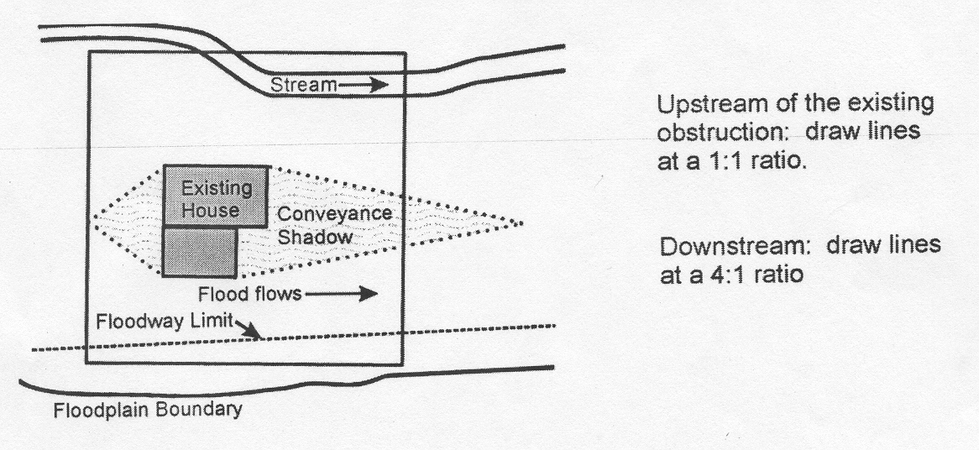
(Ord. 1251, 2008)

“County”: Douglas County, unless otherwise specified. Moved to 1.14

“Critical structures”: Any structure for which even a slight chance of flooding would reduce or eliminate its designed function of supporting a community in an emergency. Such structures included but are not limited to fire stations, hospitals, municipal airports, police stations, communication antennas or towers, elderly care facilities, fuel storage facilities, schools designated as emergency shelters, fresh waster and sewage treatment facilities. Moved to Article 5: Floodplain Management

“Cross lot drainage”: A drainage system that conveys site run-off towards the lower lot line which it is captured in a drainage channel, pipe, or similar structure and directed across lot lines to an approval point of discharge, or detention or retention structure. Moved to Article 5: Floodplain Management

“Cumulative Substantial Improvement”: Improvements, modifications, or additions to existing building are counted cumulatively for at least ten years, and reconstruction and repairs to damaged buildings are counted cumulatively for a least ten years. When the improvements, modifications, additions, reconstruction or repairs equals or exceeds the 49% substantial improvement threshold, the entire structure must be brought up to current floodplain standards. For the purposes of determining substantial improvements, market value pertains only to the structure in question. It does not include the land, landscaping or detached accessory structures on the property. Moved to Article 5: Floodplain Management

“Cumulative substantial damage”: The total cost of all repairs to a repetitive loss structure shall not cumulatively increase the market value of the structure more than 49 percent of the market value during the life of the structure. When the improvements, modifications, additions, reconstruction or repairs equals or exceeds the 49 percent substantial damage threshold, the entire structure must be brought up to current floodplain standards. This term does not, however, include either:
a. Any project for improvement of a structure to correct existing violations of state or local health, sanitary, or safety code specifications which have been identified by the local code enforcement official and which are the minimum necessary to assure safe living conditions; or
b. Any repair of flood damage to a “historic structure,” provided the repair will not preclude the structure’s continued designation as a “historic structure.”
For the purposes of determining substantial damage, market value pertains only to the structure in question. It does not include the land, landscaping, or detached accessory structures on the property. Moved to Article 5: Floodplain Management

“Curbline”: The line at the face of the curb nearest to the street or roadway. In the absence of a curb, the curbline must be established by the county engineer. Moved to 1.14

“Date of construction”: For flood management purposes, the date that the building permit was issued provided the actual start of construction, repair, reconstruction, or improvement was within one hundred eighty (180) days of the permit date. Moved to Article 5: Floodplain Management

“Days”: Shall always be consecutive calendar days unless otherwise stated. Moved to 1.14

“Dense landscape buffer or planting screen”: Landscaping which provides screening of incompatible land uses. Landscape material shall be of a type and size that reaches maturity within three years. Moved to 1.14

“Density”: The number of dwelling units per gross acre, unless otherwise stated, for residential uses. For the purpose of Transfer Development Rights, “density” shall mean the number of development rights for the parcel in question under current zoning district regulations. Moved to 1.14

“Density transfer”: An increase in density on one portion of a property to a level that may exceed the underlying mater plan designation of that portion of the property while maintaining a gross density over the entire property that is consistent with the underlying master plan designation. Moved to 1.14

“Department”: The Douglas County Community Development Department, unless otherwise specified. Moved to 1.14

“Design flood elevation (DFE)”: The elevation to which development in the regulatory floodplain is built. The minimum requirement for this elevation in NFIP communities is the base flood elevation (BFE). In areas where a higher degree of protection is promoted or required, a freeboard is added; in this case, the DFE is some height (1, 2, or more feet) above the BFE. Moved to Article 5: Floodplain Management

“Design manual”: The adopted Douglas County Design Criteria and Improvement Standards manual, unless otherwise specified. Moved to 1.14

“Designated floodway”: The channel (including the thalweg) of a stream and the portion of the adjoining floodplain designated by a regulatory agency to be kept free of further development to provide for unobstructed passage of flood flows. Moved to Article 5: Floodplain Management
“Designated official”: A person or persons authorized to take final action upon a development permits. Moved to 1.14

“Detached”: Any building or structure that does not have a wall or roof in common with any other building or structure. Moved to 1.14

“Developer”: The person or persons who have made an application to Douglas County to perform development. Moved to 1.14

“Development”: The placement or erection of any solid material or structure; discharge or disposal of any dredged material or any gaseous liquid, solid or thermal waste, grading, removing, dredging, or mining or extraction of any soil or materials; change in the density or intensity of use of land, including, but not limited to any other division of land, change in the intensity of use of water, or of access thereto; construction, reconstruction, demolition, or alteration of the size of any structure including any facility of any private, public or municipal utility; for the purposes of hillside management, any alteration to vegetation. As used in this development code, “structure” includes but is not limited to any building, road, pipe, flume, conduit, siphon, aqueduct, telephone line, and electrical power transmission and distribution line. Moved to 1.14

“Development code”: A unified text incorporating those areas of regulation more typically presented in separate zoning and subdivision ordinances and related chapters of the county code, hereafter referred to as the “development code.” Moved to 1.14

“Development right”: The right to construct a single-family dwelling, attached or detached. (Ord. 763, 1996)

“Digital flood insurance rate map (DFIRM)”: The official map, in digital format, on which the Federal Emergency Management Agency or Federal Insurance Administration has delineated both the areas of special flood hazards and the risk premium zones applicable to the community. The DFIRM is the legal equivalent of the FIRM in communities where a DFIRM is available (See Flood Insurance Rate Map). Moved to Article 5: Floodplain Management

“Directional sign”: Any sign that directs traffic or pedestrians to a particular location. Moved to 1.14 (see signs)

“Director”: The Director of Community Development or his designee. Moved to 1.14

“Directory sign”: A sign designed as a single display, which gives information about the location of business, buildings or addresses within a mobile home, multi-family residential, commercial or industrial complex. Moved to 1.14 (see signs)

“Double-faced sign”: Any sign designed to be viewed from two directions and which at no point is thicker than 36 inches measured from exterior surface of each face and the two faces of the sign are either parallel or the angle between them is thirty degrees or less. In calculating sign area, a double-faced sign shall be counted as one sign, with the square footage measured from the largest face. Moved to 1.14 (see signs)

“Dwelling”: A structure or portion thereof designed for residential occupancy, not including hotels, motels, or boarding houses. Moved to 1.14

“Dwelling, multi-family”: A structure containing two or more dwelling units or a combination of two or more separate single-family dwellings. Moved to 1.14

“Dwelling, single family”: A dwelling unit contained within a permanent structure placed on a permanent foundation. These dwellings shall include site-built, manufactured, and modular homes.
Moved to 1.14

“Dwelling unit”: A single unit providing complete, independent living facilities for one or more persons, including permanent provisions for living, sleeping, eating, cooking, and sanitation. Moved to 1.14

“Easement”: A grant of one or more property rights by the property owner for the use by the public, a corporation or another person or entity. Moved to 1.14

“Educational institution”: A school, college or university, supported wholly or in part by public funds or giving general academic instruction equivalent to the standards prescribed by the State Board of Education. Educational facility - Buildings and uses for public or private educational or research activities associated with an academic institution which has curriculum for technical or vocational training, kindergarten, elementary, secondary, or higher education, including residential facilities for faculty, staff, and students. A school, college or university, supported wholly or in part by public funds or giving general academic instruction equivalent to the standards prescribed by the State Board of Education. Moved to 1.13

“Electrical distribution”: Structures and appurtenant facilities used for the distribution of electric energy in voltages less than 65 kv. Moved to 1.14

“Electric sign”: Any sign containing electrical wiring, but not including signs illuminated by an exterior light source. Moved to 1.14 (see signs)

“Electric substation”: An assemblage of equipment and appurtenant facilities designed for voltage transformation, or voltage control of electricity in amounts of 65 kv or more. Moved to 1.14

“Electric transmission line”: A series of three or more structures and appurtenant facilities erected above ground, supporting one or more conductors emanating from a power plant or a substation, designed to transit electric energy in voltages if 65 kv voltes or more. Moved to 1.14

“Elevation certificate”: The elevation certificate is required in order to properly rate post-FIRM buildings, which are buildings constructed after publication of the Flood Insurance Rate Map (FIRM), for flood insurance Zones A1—A30, AE, AH, A (with BFE), VE, V1—V30, V (with BFE), AR, AR/A, AR/AE, AR/A1—A30, AR/AH, and AR/AO. The elevation certificate is not required for pre-FIRM buildings unless the building is being rated under the optional post-FIRM Flood insurance rules. Moved to Article 5: Floodplain Management

“Enclosure”: That portion of an elevated building below the lowest elevated floor that is either partially or fully shut-in by rigid walls (including breakaway walls). Enclosures below the Base Flood Elevation can only be used for parking, building access, and storage and must meet other construction requirements. Moved to Article 5: Floodplain Management

“Encroachment”: For the purposes of flood management only, an encroachment is any physical object placed in the floodplain that hinders the passage of water or otherwise affects flood flows, such as fill, excavation, equipment, materials or buildings. Moved to Article 5: Floodplain Management

“Erect”: to building, construct, attach, hang, place, suspend, affix or fabricate, which shall also include painting of wall signs and window signs or other graphics. Moved to 1.14

“Erosion”: The process of the gradual wearing away of any landmass. Moved to Article 5: Floodplain Management

“Family”: One or more persons occupying a dwelling unit and living as a single, nonprofit housekeeping unit; provided that a group of four or more persons who are not within a second degree of consanguinity shall not be deemed to constitute a family.
Notwithstanding the definition in the preceding paragraph, a family shall be deemed to include three or more persons not within the second degree of consanguinity occupying a dwelling unit and living as a single, nonprofit housekeeping unit, if the occupants are handicapped persons as defined in Title VII of the Civil Rights Act of 1968, as amended by the Fair Housing Amendments Act of 1988. Such unrelated individuals shall have the right to occupy the dwelling unit in the same manner and to the same extend as a family unit as defined in the first paragraph of this definition. Moved to 1.14

“Federal Emergency Management Agency (FEMA)”: The federal agency under which the National Flood Insurance Program (NFIP) is administered. Moved to Article 5: Floodplain Management

“Federal Insurance Administration (FIA)”: The government unit, a part of Federal Emergency Management Agency (FEMA), that administers the National Flood Insurance Program (NFIP). Moved to Article 5: Floodplain Management

“Fence”: Means a barrier constructed of wood, metal wire, erosion control fabric, boards or other materials and which is intended to demarcates a boundary, separate land uses, secure animals, enclose property, and/or exclude people and animals from a designated area. Solid fencing is fencing that impairs through vision, is sight obscuring or opaque, and may conflict with vehicle sight distance. Chain link fencing with privacy slats will be considered solid fencing. Moved to 1.14

“Federal Register”: A document published daily by the Federal Government that provides a uniform system for making available to the public regulations and legal notices issued by federal agencies. Moved to 1.14

“Five-hundred-year flood”: A flood with a 0.2% (or 1 in 500) annual chance of occurrence. The area of flooding caused by this flood is used to designate base floodplains of lesser hazards, such as areas protected by levees from the 100-year flood, or shallow flooding areas with average depths of less than one foot or drainage areas less than one square mile. Moved to Article 5: Floodplain Management

“Flag”: An article of cloth, paper, or similar lightweight material, varying in size, shape, or design, usually attached at one edge to a staff or cord. Moved to 1.14

“Flag, official”: The flag of the United States or other officially recognized country, state, governmental agency or Douglas County. Moved to 1.14

“Flash flood”: A flood that crests in a short length of time and is often characterized by high velocity flows. It is often the result of heavy rainfall in a localized area. Moved to Article 5: Floodplain Management

“Flashing sign”: An illuminated sign in which artificial light is not maintained in a stationary or constant intensity. Moved to 1.14 (see signs)

“Flicker or shadow flicker”: The effect that results when the shadow cast by the rotating blade of a wind energy system moves across a fixed point. Moved to 1.14

“Flood or flood waters”: A general and temporary condition of partial or complete inundation of normally dry land areas from the overflow of inland waters; the unusual and rapid accumulation or runoff of surface waters from any source and mudslides. Moved to Article 5: Floodplain Management

“Flood boundary and floodway map (FBFM)”: An official map of a community where the boundaries of the flood, mudslide and related erosion areas having special hazards have been designated zones A, M, or E. Moved to Article 5: Floodplain Management

“Flood control”: Keeping flood waters away from specific developments or populated areas by the construction of flood storage reservoirs, channel alterations, dikes and levees, bypass channels, or other engineering works. Moved to Article 5: Floodplain Management

“Flood depth”: The difference in height between the water surface elevation at the time of flooding and the normal grade elevation of the flooded area. Moved to Article 5: Floodplain Management

“Flood frequency”: A statistical expression of the average time period between floods equaling or exceeding a given magnitude. Moved to Article 5: Floodplain Management

“Flood insurance rate map (FIRM)”: An official map on which the Federal Emergency management Agency (FEMA) has delineated both the areas of special flood hazards and the risk premium zones applicable to the community. Moved to Article 5: Floodplain Management

“Flood Insurance Study (FIS)”: The official report provided by the Federal Insurance Administration that includes flood profiles and the water surface elevation of the base flood. Moved to Article 5: Floodplain Management

“Flood proofing”: Any combination of structural and nonstructural additions, changes, or adjustments to structures which reduce or eliminate flood damage to real estate or improved property, water and sanitary facilities, structures and the content. Refer to FEMA Technical Bulletins TB-1 (Openings in Foundation Walls and Walls of Enclosures, 2008), TB-3 (Non-residential Floodproofing – Requirements and Certification, 1993), and TB-7 (west Floodproofing Requirements, 1993), and all subsequent amendments and revisions, for guidelines on dry and wet floodproofing. Moved to Article 5: Floodplain Management

“Flood resistant”: Building materials capable of withstanding direct and prolonged contact with floodwaters without sustaining significant damage. The term prolonged contact means at least 72 hours, and the term significant damage means any damage requiring more than low-cost cosmetic repair (such as painting). Moved to Article 5: Floodplain Management

“Flood venting”: See applicable Standards for Construction, 20.50.230. Moved to Article 5: Floodplain Management

“Flood zones”: Moved to Article 5: Floodplain Management

“Flood zone A”: Special flood hazard areas inundated by the 100-year flood; base flood elevations are not determined.

“Flood zones AE”: Special flood hazard areas inundated by the 100-year flood; base flood elevations are determined.

“Flood zone AH”: Special flood hazard areas inundated by the 100-year flood; flood depths of 1 to 3 feet (usually areas of ponding); base flood elevations are determined.

“Flood zone AO”: Special flood hazard areas inundated by the 100-year flood; with flood depths of 1 to 3 feet (usually sheet flow on sloping terrain); average depths are determined. For areas of alluvial fan flooding, velocities are also determined.

“Flood zone AR”: Special flood hazard areas that result from the decertification of a previously accredited flood protection system that is in the process of being restored to provide a 100-year or greater level of flood protection. After restoration is complete, these areas will still experience residual flooding from other flooding sources.

“Flood zone D”: Areas in which flood hazards are undetermined, but possible.

“X-shaded flood zone”: A moderate flood hazard area between the limits of the 100-year and 500-year flood zones with average depth of flood of less than 1 foot or with contributing drainage area less than 1 square mile. Also known as Zone B and includes areas protected by levees from the base flood.

“X-unshaded flood zone”: Area of minimal flood hazard determined to be outside the 500-year floodplain. Also known as Zone C. This area may have localized ponding or flooding.

“Floodplain and flood-prone area”: Means any land area susceptible to being inundated by water from any source – see Flood, or flood waters. Moved to Article 5: Floodplain Management

“Floodplain administrator”: The individual appointed to administer and enforce the floodplain management regulations. Moved to Article 5: Floodplain Management

“Floodplain management”: The operation of an overall program of corrective and preventive measures for reducing flood damage and preserving and enhancing, where possible, natural resources in the floodplain, including but not limited to emergency preparedness plans, flood control works and floodplain management regulations and ordinances. Moved to Article 5: Floodplain Management

“Floodplain management regulations”: This chapter, and any federal, state or local regulations plus community zoning ordinances, subdivision regulations, building codes, health regulations, special purpose ordinances (such as a grading and erosion control) and other applications of police power which control development in flood-prone areas to prevent and reduce flood loss and damage. Moved to Article 5: Floodplain Management

“Flood-related erosion”: The collapse or subsidence of land along the shore of a lake or other body of water as a result of undermining caused by waves or currents of water exceeding anticipated cyclical levels or suddenly caused by an unusually high water level in a natural body of water, accompanied by a severe storm, or by an unanticipated force or nature, such as a flash flood or an abnormal wave action, or by some similarly unusual and unforeseeable event which results in flooding. Moved to Article 5: Floodplain Management

“Flood-related erosion area management”: The operation of an overall program of corrective and preventive measures for reducing flood-related erosion damage, including but not limited to emergency preparedness plans, flood-related erosion control works, and floodplain management regulations. Moved to Article 5: Floodplain Management

“Flood-related erosion prone area”: A land area adjoining the shore of a lake or other body of water, which due to the composition of the shoreline or bank and high water levels or wind-driven currents, is likely to suffer flood-related erosion damage. Moved to Article 5: Floodplain Management

“Floodway”: The channel of a river or other watercourse and the adjacent land area that must be reserved in order to discharge the base flood without cumulatively increasing the water surface elevation. Moved to Article 5: Floodplain Management

“Floor area ratio”: Determined by dividing the gross floor area of all buildings on a lot by the area of that lot. Moved to 1.14

“Footing”: The enlarged base of a foundation wall, pier, or column, designed to spread the load of the structure so that it does not exceed the soil bearing capacity. Moved to 1.14

“Foundation”: The underlying structure of a building, usually constructed of concrete, that supports the foundation walls, piers, or columns. Moved to 1.14

“Foundation walls”: A support structure that connects the foundation to the main portion of the building or superstructure. Moved to 1.14

“Freeboard”: A margin of safety usually expressed in feet above a flood level for purposes of flood plain management. Freeboard tends to compensate for the many unknown factors that could contribute to flood heights greater than the height calculated for selected size flood and floodway conditions, such as wave action, bridge openings, and the hydrological effect of urbanization of the watershed. Moved to Article 5: Floodplain Management

“Freestanding sign”: See monument sign. Moved to 1.14 (see signs)

“Front wall”: The nearest wall of a structure to the street upon which the structure faces, but excluding cornices, canopies, eaves, or any other architectural embellishments. Moved to 1.14

“Frontage”: The side of a lot abutting a street (the front lot line). Moved to 1.14

“Frontage of property”: The longest single, lineal dimension of a parcel of property abutting on a public street. Moved to 1.14

“Fuel break”: A strategically located strip or block of land, varying in width, on which vegetation has been modified to provide a safer place for fire fighters to work and to help reduce the rate of fire spread. Moved to 1.14

“Functionally dependent use”: For flood management purposes, a use which cannot perform its intended purpose unless it is located or carried out in close proximity to water. The term includes only marina facilities, port facilities that are necessary for the loading and unloading of cargo or passengers, and boat building and boat repair facilities, but does not include long-term storage or related manufacturing facilities. Moved to Article 5: Floodplain Management

“Garage”: An enclosed building, or a portion of an enclosed building used for the parking of vehicles, and not designed for human habitation. Moved to 1.14

“Gas distribution line”: Mains, services, equipment and appurtenant facilities which carry or control the supply of gas from the point of local supply to and including the sales meter. Moved to 1.14

“Gas regulator station”: As assemblage of equipment which reduces, regulates and meters natural gas pressure in the transmission line, holder, main, pressure vessel or the compressor station piping. This may include auxiliary equipment such as valves, control instruments or control lines as well as piping. Moved to 1.14

“Grade”: The degree of rise or descent of a sloping surface expressed as a ratio or percentage (see Slope). Moved to 1.14

“Graphics”: The noninternally illuminated decoration of the exterior of a building or site which murals, art work, statuary, and the like, not containing a commercial message, trademark, logo type, brand name, or the like. Moved to 1.14

“Ground cover”: Plants, other than turf grass, normally reaching an average maximum height of not more than two feet at maturity. Moved to 1.14

“Grubbing”: The clearing of roots and stumps. Moved to 1.14

Recovery house - A residence that provides housing and a living environment for persons recovering from alcohol or other substance use disorders and is operated to facilitate their reintegration into the community but does not provide any treatment for alcohol or other substance use disorders. The term does not include a facility for transitional living for released offenders. Moved to 1.13

“Hanging sign”: A sign attached to and located below any eave, roof, canopy or awning. Moved to 1.14 (see signs)

“Hardship”: For flood management purposes as related to Variances, an exceptional hardship would result from a failure to grant the requested variance. The Board of Commissioners requires the variance to be exceptional, unusual, and pertain only to the property involved. Moved to Article 5: Floodplain Management

“Hearing body”: The appointed or elected person or person authorized to render a final decision on any development application. Moved to 1.14

“HEC-RAS”: One of the family of water surface modeling tools publicly available through the US Army Corps of Engineers, Hydraulic Engineering Center. Moved to Article 5: Floodplain Management

“Hedge”: A landscape barrier consisting of a continuous, dense planting of shrubs. Moved to 1.14 (see signs)

“Height of structure”: The vertical distance from any part of the structure to the natural grade below, excluding chimneys and vents. Moved to 1.14 (see signs)

“Highest adjacent grade”: The highest natural elevation of ground surface prior to construction next to the proposed walls of a structure. Moved to 1.14 (see signs)

“Hillside area”: Any property containing slope areas of 15 percent or greater as designated on the Master Plan slope constraint maps. Moved to 1.14 (see signs)

"Historic structure": For flood management purposes, any structure that is:
a. Listed individually in the National Register of Historic Places (a listing maintained by the Department of Interior) or preliminarily determined by the Secretary of the Interior as meeting the requirements for individual listing on the National Register;
b. Certified or preliminarily determined by the Secretary of the Interior as contributing to the historical significance of a registered historic district or a district preliminarily determined by the Secretary to qualify as a registered historic district;
c. Individually listed on a State inventory of historic places in states with historic preservation programs which have been approved by the Secretary of Interior; or
d. Individually listed on a local inventory of historic places in communities with historic preservation programs that have been certified either by an approved State program as determined by the Secretary of the Interior or directly by the Secretary of the Interior in states without approved programs. Moved to Article 5: Floodplain Management

“Holiday decoration”: Decorations commonly associated with any national, local or religious holiday. Moved to 1.14

“Home occupation”: A business conducted as an accessory use to a principal residential dwelling which is occupied by the business owner. Moved to 1.14

“Horizontal and vertical building envelopes”: The maximum width and height of a structure based on minimum setback requirements and maximum building height limitations for the zone within which the project is located. These envelopes may be utilized to evaluate visual impacts when specific architectural plans are not provided for subdivision review. Moved to 1.14

“Hotel”: Guest rooms or suites occupied on a transient basis, with most rooms gaining access from an interior hallway and with no provisions for cooking in an individual unit. Moved to 1.13

“Hydraulics”: The science that deals with practical applications of water in motion. Moved to 1.14

“Hydrodynamic loads”: Forces imposed on structures by waters due to the impact moving water on the upstream side of the structure, drag along its sides, and eddies or negative pressures on its downstream side. Moved to Article 5: Floodplain Management

“Hydrology”: The science of the behavior of water in the atmosphere, on the earth’s surface, and underground. Moved to Article 5: Floodplain Management

“Hydrostatic loads”: Forces imposed on structures due to the weight of the water. Moved to Article 5: Floodplain Management

“Illuminated, exterior”: The lighting of a sign or sign structure by lights shining onto the surface of the sign. Moved to 1.14 (see signs)

“Illuminated, interior”: The lighting of a sign or sign structure by lights contained within the sign, and shining out through the translucent surfaces of the sign. Moved to 1.14 (see signs)

“Inaugurate”: The issuance of a building permit or site improvement permit. Moved to 1.14 (see signs) Moved to 1.14

“Incombustible material”: Any material which will meet the requirements of the Uniform Building Code or approved standards for Douglas County. Moved to 1.14

“Incompatibility of land uses”: The proximity or direct association of contradictory, incongruous, or discordant land use or activities, including the impact of noise, traffic, vibration, smoke, odors, and other similar environmental conditions. Moved to 1.14

“Independent congregate senior living community”: An independent living community that entails private dwelling units/apartments designed for an adult population aged 55 years and older that may include some supportive services including, but not limited to, meals, housekeeping, home health, and other supportive services. A number of common facilities, including kitchen facilities, club houses, pools, health facilities, and other personal services, may be provided on the site. Moved to 1.13

“Indoor Gun Range”: An enclosed facility or area used for archery or the shooting of firearms, whether for practice or sport. Moved to 1.13

“Inflatable sign or inflatable device”: Any device, or grouping of balloons, larger than six feet in its longest dimension which is supported by air pressure or inflated with air or gas which is used to attract the attention of the public, whether or not it displays any specific advertising message. Moved to 1.14 (see signs)

“Internal driveway”: For purposes of determining monument sign placement for a parcel of record located within a commercial or industrial complex, an internal driveway is a driveway or drive aisle located internal to the complex which provides access to the parcel and which does not abut or front on a public street. Moved to 1.14

“Irrigation system”: A permanent, artificial watering system designed to transport and distribute water to plants. Moved to 1.14

“Junk yard and salvage facilities”: Primary or accessory use of structures or land for storage, dismantling or selling of cast-off, unused, scrap or salvage material of any sort. Moved to 1.13

“Kiosk”: A small, freestanding structure permanently affixed to the ground, requiring a building permit, which may have one or more surfaces used to display one or more advertising signs. Moved to 1.14

“Kitchen”: Any room, all or part of which is designed or used for storage, refrigeration, cooking and the preparation of food. Moved to 1.14

“Lake Tahoe region”: That portion of the Lake Tahoe basin in Douglas County, Nevada, as delineated on the official maps of the Tahoe Regional Planning Agency. Moved to 1.14

“Land use zoning district”: A portion of the county within which certain uses of land and structures are defined, and regulations are specified. Moved to 1.14

“Landscaping”: Any combination of living plants such as grass, ground cover, shrubs, flowers, vines, hedges, or trees, and nonliving landscape material such as rocks, pebbles, sand, mulch, bark, walls, fences, and decorative paving materials (excluding driveways, parking, loading, or storage areas), and sculptural elements. Moved to 1.14

“Letter of map amendment (LOMA)”: The procedure by which any owner or lessee of property who believes his property has been inadvertently included in a special flood hazard may submit scientific and technical information to the Federal Insurance Administrator for review to remove the property from said area. The administrator will not consider a LOMA if the information submitted is based on alteration of topography or new hydrologic or hydraulic conditions since the effective date of the FIRM. Moved to Article 5: Floodplain Management

“Letter of map revision (LOMR)”: An official revision to a currently effective FIRM. A LOMR officially changes flood zone, floodplain and floodway designations, flood elevations and planimetric features. Moved to Article 5: Floodplain Management

“Letters of map revision (Based on Fill) (LOMR-F)”: A letter from FEMA stating that an existing structure or parcel of land that has been elevated by fill would not be inundated by the base flood. ( Moved to Article 5: Floodplain Management

“Levee”: A man-made structure, usually an earthen embankment, designed and constructed in accordance with sound engineering practices to contain, control, or divert the flow of water so as to provide protection from temporary flooding. Moved to Article 5: Floodplain Management

“Levee system”: A flood protection system which consists of a levee, or levees, and associated structures, such as closure and drainage devices, which are constructed and operated in accord with sound engineering practices. Moved to Article 5: Floodplain Management

“Lighting, direct”: Illuminating a sign or sign structure by a light source seen directly. Moved to 1.14 (see signs)

Lighting, indirect: The illumination of a sign or sign structure by a light source not Moved to 1.14 (see signs)

Livable area: Interior floor area of a residential use which includes bedrooms, bathrooms, kitchens, closets, but excludes garages. Moved to 1.14

“Lot”: A parcel, tract or area of land established by plat, subdivision, or as otherwise permitted by law, to be used, developed or built upon and which abuts upon a legal means of access. The classifications of lots are: Moved to 1.14

“Corner”: A lot located at the intersection of two or more streets at an angle or not more than 135 degrees. If the angle is greater that 135 degrees, the lot shall be considered an “interior lot.”

“Flag”: A lot having access or an easement to a public or private street by a narrow, private right-of-way.

“Interior”: A lot abutting only one street.

“Key”: A lot with a side line that abuts the rear line of any one or more adjoining lots.

“Reverse corner”: A corner lot, the rear of which abuts the side of another lot.

“Through”: A lot having frontage on two generally parallel sheets, with only one primary access.
“Lot area”: The total horizontal area included within the lot lines of a lot. Moved to 1.14

“Lot depth”: The average distance between the front and rear lot lines or between the front line and the intersection of the two side lines, if there is no real line. Moved to 1.14

“Lot frontage”: The portion of the lot contiguous to the street. Moved to 1.14

“Lot line”: Any boundary of a lot. The classification of lot lines are: Moved to 1.14

“Front”: On an interior lot, the line separating the parcel from the street. On a corner lot, both lot lines abutting a street. On a through lot, the lot line abutting the street providing the primary access to the lot.

“Interior”: Any lot line not abutting a street.

“Rear”: A lot line, not intersecting a front lot line, which is most distant from and most closely parallel to the front lot line. In the case of an irregularly shaped lot or a lot bounded by only three lot lines, a line within the lot having a length of at least ten feet, parallel to and most distant from the front lot line shall be interpreted as the rear lot line for the purpose of determining required yards, setbacks, and other provisions of this code.

“Side”: Any lot line which is not a front or rear lot line. Moved to 1.14

“Lot width”: The horizontal distance between the side lot lines, measured at right angles to the lot depth at a midway point between the front and rear lot lines. Moved to 1.14

“Lowest floor”: In Special Flood Hazard Areas or X-shaded flood zones, the lowest floor is determined based on the following type of construction methods: Moved to Article 5: Floodplain Management

“Below grade crawlspace construction”: Subgrade enclosures are prohibited that are not constructed to meet the provisions of section 20.50.230. If constructed to meet section 20.50.230 the lowest floor is the top of the subfloor. Moved to Article 5: Floodplain Management

“Crawlspace construction placed on fill”: The lowest floor is the bottom of the crawlspace. Moved to Article 5: Floodplain Management

“Manufactured homes”: The lowest floor for manufactured homes is the base of the manufactured home including all duct work, and electrical wiring, etc., providing that the skirting or foundation is wet floor proofed (vented). Moved to Article 5: Floodplain Management

“Slab on grade construction”: the lowest floor is the top of the slab. Moved to Article 5: Floodplain Management

“Structures with basements”: The lowest floor is the top of the basement slab. An unfinished or flood resistant enclosure used solely for paring of vehicles, access, or storage in an area other than a basement areas, is not considered a building’s lowest floor. Moved to Article 5: Floodplain Management

“Main structure”: A structure used for the principal use of the property as distinguished from an accessory use. Moved to 1.14

“Manufactured home”: A residential dwelling built in accordance with the Federal Manufactured Home Construction and Safety Standards. For floodplain administration purposes, the term manufactured home also includes travel trailers and other similar vehicles placed on a site for greater than one hundred eighty consecutive days. Moved to 1.14

“Manufactured home park or subdivision”: A parcel or contiguous parcels of land divided into two or more manufactured home lots or sites for rent or sale. Moved to 1.14

“Manufactured home (mobile home) park or subdivision, existing”: A manufactured home park or subdivision for which the construction of facilities for servicing the lots on which the manufactured homes are to be affixed, including, at a minimum, the installation of utilities, the construction of streets, and either final site grading or the pouring of concrete pads, is completed before the effective date of the floodplain management regulations adopted by a community. Moved to 1.14

“Manufactured home (mobile home) park or subdivision, expansion to”: The preparation of additional sites by the construction of facilities for servicing the lots on which the manufactured homes are to be affixed, including the installation of utilities, construction of streets, and either final site grading or the pouring of concrete pads. Moved to 1.14

“Manufactured home (mobile home) park or subdivision, new”: A manufactured home park or subdivision for which the construction of facilities for servicing the lots on which the manufactured homes are to be affixed, including, at a minimum, the installation of utilities, the construction of streets, and either final site grading or the pouring of concrete pads, is completed on or after the effective date of the floodplain management regulation adopted by the county. Moved to 1.14

“Manufactured slope”: A man-made slope created by grading that consists wholly of cut or filled material. Moved to 1.14

Cannabis Establishment - A facility engaged in the cultivation, production, testing, distribution, retail sale, or retail consumption of cannabis or cannabis products, whether for medical or adult recreational use. This includes, but is not limited to: cultivation facilities, testing laboratories, production facilities, dispensaries, and distributors, whether for medical or adult recreational use. Cannabis Establishments are defined in and regulated under NRS Chapters 678A through 678D, and such definitions are hereby incorporated by reference.

Cannabis Establishments, as defined above, are prohibited in all zoning districts and shall not be permitted as a primary, accessory, special, or temporary use. This prohibition does not apply to the lawful, non-commercial personal cultivation or use of cannabis as authorized under NRS Chapters 678C or 678D. Moved to 1.13

“Market value”: For flood management purposes and determining substantial improvement, market value pertains only to the structure in question. It does not pertain to the land, landscaping, or detached accessory structures on the property. For determining improvement, the value of the land must always be subtracted.
Acceptable estimates of market value can be obtained from the following sources:
a. Independent appraisals by a professional appraiser; or
b. Detailed estimates of the structure's Actual Cash Value (used as a substitute for market value based on the preference of the community); or
c. Property appraisals used for tax assessment purposes (Adjusted Assessed Value: used as a screening tool); or
d. The value of buildings taken from NFIP claims data (used as a screening tool); or
e. "Qualified estimates" based on sound professional judgment made by staff of the local building department or local or State tax assessor's office.
As indicated above, some market value estimates should only be used as screening tools to identify those structures where the substantial improvement ratios are obviously less than or greater than fifty percent (50%) (e.g., less than forty percent (40%) or greater than sixty percent (60%)). For structures that fall between the forty percent (40%) and sixty percent (60%) range, more precise market value estimates should be used. Moved to Article 5: Floodplain Management

“Master sign plan”: An architectural design plan describing the content of all proposed signs in terms of size, shape, materials, colors, lettering style, placement, lighting, and the like, to set forth a basic identity for each unit of operation for a business complex. A master sign plan is required for a commercial or industrial complex containing three or more units of operation. Upon approval, the master sign plan must apply to all units of operation. Upon approval, the master sign plan must apply to all units of operation within the business complex. ( Moved to 1.14 (see signs)

“Mean sea level”: For the purposes of the National Flood Insurance Program, the National Geodetic Vertical Datum (NGVD) of 1928 or other datum, to which base flood elevations shown on a community’s Flood Insurance Rate Map are referenced. Moved to Article 5: Floodplain Management

“Median”: A paved or planted area separating a street or highway into two or more lanes of opposite direction of travel. Moved to 1.14

“Mixed-use development”: The development of parcels or structures with two or more different land uses such as, but not limited to, a combination of residential, office, manufacturing, retail, public or entertainment in a single or physically integrated group of structures. Moved to 1.14

“Mobile sign”: A sign attached to or suspended from any type of vehicle. (Ord. 763, 1996; Ord. 386, 1981) Moved to 1.14 (see signs)

“Modular home”: A structure intended for residential use and manufactured off-site in accordance with all other codes adopted by Douglas County. Moved to 1.14

“Monument sign”: An independent structure supported from a maximum of two feet above grade to the bottom of the sign with a solid base of at least 80% of the total sign structure width. Moved to 1.14 (see signs)

“Motel”: Guest rooms or suites occupied on a transient basis, with most rooms gaining access from an exterior walkway and with no provisions for cooking in an individual unit. Moved to 1.13

“Mudslide”: A condition where there is a river, flow or inundation of liquid mud down a hillside usually as a result of a dual condition of loss of brush cover, and the subsequent accumulation of water on the ground preceded by a period of unusually heavy or sustained rain. A mudslide may occur as a distinct phenomenon while a landslide is in progress, and will be recognized as such by the Federal Insurance Administrator only if the mudflow, and not the landslide, is the proximate cause of damage that occurs. Moved to Article 5: Floodplain Management

“Mulch”: Nonliving organic and synthetic materials customarily used in landscape design to retard erosion and retain moisture.

“National geodetic vertical datum (NGVD)”: As corrected in 1929, is a vertical control used as a reference for establishing varying elevations within the floodplain. Moved to Article 5: Floodplain Management

“Natural area”: A land area, unimproved and not occupied by any structures or manmade elements, set aside for the conservation of permanent, undisturbed open space. Moved to 1.14

“Natural drainage”: Water which flows by gravity in channels by the surface topography of the earth prior to changes made by the efforts of man. Moved to Article 5: Floodplain Management

“Natural grade”: The grade unaffected by construction techniques such as fill, landscaping, or berming. Moved to 1.14

“NAVD88”: North American Vertical Datum of 1988. Moved to 1.14

“NGVD29”: National Geodetic Vertical Datum of 1929. Moved to 1.14

“Net consumptive use”: Net consumptive use means that portion of irrigation water applied to vegetation which is consumed and removed from the local hydrological environment by evaporation or transpiration. The Alpine decree has interpreted the net consumptive use of surface water for irrigation of the lands above Lahontan Reservoir (including Carson Valley) to be 2.5 acre-feet per acre. Moved to 1.14

“Net site area”: The total area within the lot lines of a lot or parcel of land after public street easements or other areas to be dedicated or reserved for public use are deducted from such lot or parcel. Moved to Article 5: Floodplain Management

“New construction”: For floodplain management purposes, structures for which “the start of construction” commenced on or after the effective date of the floodplain management regulations adopted by the county, and includes any subsequent improvements so such structures, where the construction involves an increase in gross floor area of greater than 100 square feet. Solar Photovoltaic Facility

“Noncommercial sign”: Any sign which is intended to convey a noncommercial message of social, political, educational, religious or charitable commentary. Moved to 1.14 (see signs)

“Nonconforming, illegal”: A structure, lot, or use which did not conform to applicable laws when constructed or initiated, and does not conform to the provisions of the current development code. Moved to 1.14

“Nonconforming lot”: A lot, the area, frontage or dimensions of which do not conform to the provisions of the current development code. Moved to 1.14

“Nonconforming sign”: A sign which may have been validly installed under laws or ordinances in effect prior to the effective date of the ordinance codified in this title, but which is not in conflict with the provisions of this title. Moved to 1.14 (see signs)

“Nonconforming structure”: A structure which conformed to applicable laws when constructed but does not conform to the provisions of the current development code. Moved to 1.14

“Nonconforming use”: A use which conformed to the applicable laws when established but does not conform to the provisions of the current development code. Moved to 1.14

“Nonrestricted license”: A gaming license which permits the operation of more than fifteen slot machines and other games. Moved to 1.14

“NRS”: Nevada Revised Statutes. Moved to 1.14

“Nude”: A person completely without clothing or covering. Moved to 1.14

“Obstruction”: Includes, but is not limited to, any dam, wall, wharf, embankment, levee, dike, pile, abutment, protection, excavation, channelization, bridge, conduit, culvert, building, wire, fence, rock, gravel refuse, fill, structure, vegetation or other material in, along, across or projecting into any watercourse which propensity to snare or collect debris carried by the flow of water, or its likelihood of being carried downstream. Moved to 1.14

“Off-premises sign”: A sign, including portable sandwich or A-frame signs, which advertises or informs about goods, products, services or uses not directly concerning the use on the property upon which the sign is located. Moved to 1.14 (see signs)

“On-premises sign”: Any sign which advertises goods sold, manufactured or produced, service or uses rendered on the property upon which the sign is located, or the name of the business enterprise. Moved to 1.14 (see signs)

“Open space”: All areas of natural plant communities or areas replanted with vegetation after construction including but not limited to revegetated natural areas, trees, shrubs, hedges, lawn, and ground cover planting areas, which provide light and air and are designed for either environmental, scenic, amenity, or recreational purposes. Moved to 1.14

“Ornamental tree”: A deciduous tree planted primarily for its ornamental value or for screening purposes; tends to be smaller at maturity than a shade tree. Moved to 1.14

“Parcel”: A parcel of land under one ownership that has been legally subdivided or combined. Moved to 1.14

“Parking areas”: Those are including parking lots, driveways, drive aisles, loading and unloading spaces, and all other areas necessary to move vehicles in and out of required parking spaces. Moved to 1.14

“Parking lot sales”: See Sidewalk and parking lot sales. Moved to 1.13

“Parkway”: The area of a public right-of-way that lies between the curb and the adjacent property line or physical boundary definition such as fences or walls, which is used for landscaping or passive recreational purposes. Moved to 1.14

“Pennant”: A piece of cloth, plastic, paper, or other such material varying in size, shape or design, erected as an advertising device to draw attention to the site where located. Moved to 1.14 (see signs)

“Permanent sign”: Any sign which from the nature and effect of its proposed composition, construction, the message to be carried or its proposed placement, would make it reasonable to determine that it was intended for continuous display for a period of time greater than 90 calendar days. Moved to 1.14 (see signs)

“Permitted use”: Any use allowed in a land use zoning district and subject to the provisions applicable to that district. Moved to 1.14

“Person”: Any individual, firm, copartnership, joint venture, association, social club, fraternal organization, company, joint stock association, corporation, estate, trust, organization, business, business trust, public agency, school district, State of Nevada, and its political subdivisions or instrumentalities, receiver, syndicate or any group or combination thereof, acting as a unit, including any trustee, receiver or assignee. Moved to 1.14

“Physical map revisions (PMR)”: A reprinted NFIP map incorporating changes to floodplains, floodways, or flood elevations. Because of the time and cost involved to change, reprint, and redistribute an NFIP map, a PMR is usually processed when a revision reflects large scope changes. Moved to Article 5: Floodplain Management

“Planned development (PD)”: A type of development characterized by comprehensive planning for the project as a whole, clustering of structures to preserve usable open space and other natural features, and a mixture of housing types within the prescribed densities. Moved to 1.14

“Portable freestanding sandwich or “A-frame” type sign”: A sign that is designed to be moveable and is not structurally attached to the ground, a building, a structure or any other sign. Such sign may or may not be in the configuration of an “A.” Moved to 1.14 (see signs)

“Political sign”: A sign designed for the purpose of advertising support of or opposition to a candidate or proposition at a public election. Moved to 1.14 (see signs)

“Ponding hazard”: A flood hazard that occurs in flat areas when there are depressions in the ground that collect "ponds" of water. The ponding hazard is represented by the zone designation AH on the FIRM. Moved to Article 5: Floodplain Management

“Post-FIRM Construction”: Construction or substantial improvement that started on or after the effective date of the initial Flood Insurance Rate Map (FIRM) of the community or after March 28, 1980, whichever is later. Moved to Article 5: Floodplain Management

“Predeveloped adjacent grade”: The natural elevation of ground surface prior to construction next to the proposed walls of a structure. Moved to Article 5: Floodplain Management

“Pre-FIRM Construction”: Construction or substantial improvement which started on or before March 28, 1980 or before the effective date of the initial Flood Insurance Rate Map (FIRM) of the community, whichever is later. Moved to Article 5: Floodplain Management

“Pre-lease sign”: A sign placed upon real property advertise the availability of lease space for an unconstructed building or development site. Moved to 1.14 (see signs)

“Principal use”: The primary or predominant use of any parcel, building or structure. Moved to 1.14

“Processing facility”: A building or enclosed space used for the collection and processing of recyclable materials to prepare for either efficient shipment, or to an end-user’s specifications by such means as baling, briquetting, compacting, flattening, grinding, crushing, mechanical sorting, shredding, cleaning and remanufacturing. Processing facilities include the following:

a. “Light processing facility”: Occupies an area of under 45,000 square feet of collection, processing and storage area, and averages two outbound truck shipments per day. Light processing facilities are limited to baling, briquetting, crushing, compacting, grinding, shredding and sorting of source separated recyclable materials sufficient to qualify as a certified processing facility. A light processing facility shall not shred, compact, or bale ferrous metals other than food and beverage containers. Moved to 1.13

b. “Heavy processing facility”: Any processing facility other than a light-processing facility. Moved to 1.13

“Professional sign”: A sign indicating the name and occupation of a professional person or group. Moved to 1.14 (see signs)

“Project”: See Development. Moved to 1.14

“Projecting building sign”: Any sign other than a sign mounted flush to a wall which projects more than 12 inches from and is supported by a wall or roof of a building, structure or sign structure, and projects beyond the eaves of a building. Moved to 1.14 (see signs)

“Public park”: A park, playground, swimming pool, beach, pier, reservoir, golf course or athletic field within the County which is under the control, operation, or management of the county, state, or other political subdivision. Moved to 1.13

“Public right-of-way”: A strip of land acquired by reservation, dedication, purchase, prescription, or condemnation and intended to be occupied by a road, trail, water line, sanitary sewer or other public uses. Moved to 1.14

“Public safety, nuisance”: Related to variances of this title. The granting of a variance must not result in anything which is injurious to safety or health of the community or neighborhood, or any considerable number of persons, or unlawfully obstructs the free passage or use, in the customary manner, or any way, navigable lake, river, bay stream or canal, or basin. Moved to 1.14

“Public View”: Means plainly visible from the public right-of-way, or from any adjacent public or private property. Items enclosed and visually obscured within a structure, or within a lawful fence or wall are not considered to be in public view. Moved to 1.14

“Quarry”: A place where rock, ore, stone and similar materials are excavated, processed for sale or for off site use. Moved to 1.14

“Reader board or changeable copy sign”: See Changeable copy sign. Moved to 1.14 (see signs)

“Real property sign”: A sign placed upon real property to advertise that the property upon which the sign is placed, or any piece or any interests therein, is for sale, exchange, lease, or rent. Moved to 1.14 (see signs)

“Receiving parcel”: A parcel of real property situated in a receiving area, designated as such by the 1996 Master Plan, as amended. Moved to 1.14

“Recreational vehicle (RV)”: A vehicle towed or self-propelled on its own chassis or attached to the chassis of another vehicle and designed primarily not for use as a permanent dwelling but as temporary living quarters for recreational, camping, travel, or seasonal use. The term recreational vehicle includes, but it not limited to, travel trailers, pick-up campers, camping trailers, motor coach homes, converted trucks or buses, boats and boat trailers, utility and all terrain vehicles. Moved to 1.14

“Recycling”: The process by which waste products are reduced to raw material and transformed into new products. Moved to 1.13

“Regulatory floodplain”: The floodplain to which a community applies their floodplain development regulations. A community participating in the NFIP is required to adopt the floodplain on their FIRM or use a more restrictive (larger aerial extent or higher floodplain water surface elevations) floodplain. Moved to Article 5: Floodplain Management

“Repetitive loss”: Flood-related damages sustained by a structure on two separate occasions during a 10-year period that has had at least 2 paid flood losses of more than $1,000 for each claim. Moved to Article 5: Floodplain Management

“Requirements for Areas Below the Lowest Floor”: All new construction and substantial improvements with fully enclosed areas below the lowest floor (excluding basements) that are usable solely for parking of vehicles, building access or storage, and which are subject to flooding, shall be designed to automatically equalize hydrostatic flood forces on exterior walls by allowing for the entry and exit of floodwaters. Designs for meeting this requirement shall follow the guidelines in FEMA Technical Bulletins TB-1 (Openings in Foundation Walls and Walls of Enclosures, 2008) and TB-7 (Wet Floodproofing Requirements, 1993) and must either be certified by a licensed professional engineer or architect to meet or exceed the following minimum criteria: (1) Must have a minimum of two (2) openings having a total net area of not less than one (1) square inch for every square foot of enclosed area subject to flooding; and (2) The bottom of all such openings will be no higher than one (1) foot above the lowest adjacent finished grade. Moved to Article 5: Floodplain Management

“Restricted use area”: An area that is retained in its existing state and is restricted from all development (due to proximity to a hazard or environmentally sensitive area pursuant to 20,690.030.Y.5) except for hiking trails, provided such trails neither create nor increase a public hazard. The use restrictions exclude minimal grading required to construct public utility services or roadways to adjacent properties where no technically feasible alternative route or construction method exists. Moved to 1.14

“Reverse vending machine (recycling)”: An automated mechanical device which accepts at least one or more types of empty beverage containers including, but not limited to aluminum cans, glass, and plastic bottles, and issues a cash refund or a redeemable credit slip with a value not less than the container’s redemption value as determined by the state. A reverse vending machine may sort and process containers mechanically provided that the entire process is enclosed within the machine. In order to accept and temporarily store all container types in a proportion commensurate with their relative redemption rates, and to meet the requirements of certification as a recycling facility, multiple grouping of reverse vending machines may be necessary. Moved to 1.13

“Review authority”: The person, committee, commission or board responsible for the review or final action on a land use issue. Moved to 1.14

“Ridge line”: A ground line connecting the series of highest elevation points or a ridge, running center and parallel to the long axis of the ridge. Moved to 1.14

“Right-of-way”: See Public right-of-way. Moved to 1.14

“Riverine”: Relating to, formed by, or resembling a river including but not limited to tributaries, streams, and brooks (also known as lotic).

“Roof sign”: A sign erected upon a roof, the ridge of a roof, or parapet of a building or structure and extending above the highest portion of the roof., Moved to 1.14 (see signs)

“Roof-mounted sign”: A sign erected upon a roof of a building and extending no higher than the highest portion of the roof. Moved to 1.14 (see signs)

“Roofing square”: 100 square feet of roofing surface. Moved to 1.14

“Salvage”: See Junk and salvage facilities. Moved to 1.14

“Sandwich sign”: A flat sign composed of one or more boards attached together, with supports enabling the sign to stand upright. It is designed to be a moveable unit. Moved to 1.14 (see signs)

“Screening”: A method for reducing the impact of noise and unsightly visual intrusions with less offensive or more harmonious elements, such as plants, berms, fences, walls or any appropriate combination thereof. Moved to 1.14

“Seminude”: A person whose specified anatomical areas are less than completely and opaquely covered or who appears to have human male genitals which are in a discernibly turgid state, even if completely and opaquely covered. Moved to 1.14

“Sending parcel”: A parcel of real property situated in the A-19 or FR-19 zoning districts. Moved to 1.14

“Setback”: The required distance that a building, structure, parking or other designated item must be located from a lot line. Moved to 1.14

Adult characterized businesses - Means any of the following:

- Any business wherein the preponderant business is the offering of services, materials, goods or products which are characterized by an emphasis on matter depicting, describing, or relating to nude or semi-nude persons or specified sexual activities between persons for observation by patrons. These businesses shall include, but not be limited to, adult bookstores, adult video stores, picture arcades showing adult entertainment pictures, adult motion picture theaters or other similar businesses;

- Any business which utilizes or encourages sexual arousal, sexual gratification or sexual stimulation of a customer or prospective customer in connection with the sale or offering for sale of services, goods, or materials. These businesses shall include, but not be limited to, unlicensed massage establishments, Turkish baths, nude or semi-nude modeling studios, businesses using nude or semi-nude models in offering lingerie or intimate apparel for sale, sexual catharsis centers, sexual encounter establishments, bondage or discipline parlors, escort bureaus and introductory services, or other similar businesses; or

- Any business, having as a portion of its goods for sale, products which replicate or are designed to simulate specified anatomical areas, and which are designed to be placed on specified anatomical areas to cause sexual excitement. These businesses shall include, but not be limited to, sexual novelty stores or other similar businesses.

- This definition does not apply, nor shall it be interpreted to apply, to any business conducted, operated by or employing licensed chiropractors, licensed physicians, licensed physical therapists, licensed massage therapists, licensed psychologists, licensed social workers or licensed marriage family counselors when performing functions under or pursuant to their respective licenses. Moved to 1.13

“Shade tree”: A deciduous tree planted primarily for its high crown of foliage or overhead canopy. Moved to 1.14

“Shrub”: A woody plant, smaller than a tree, consisting of several small stems from the ground or small branches near the ground; may be deciduous or evergreen. Moved to 1.14

“Sidewalk or parking lot sale”: A promotional sales event conducted by one or more businesses which is held outside the confines of the commercial or manufacturing structures in which such business is normally conducted and which sale involves the outdoor display within a paved or concrete area on the same lot as the structures of merchandise which is normally displayed within the structures. Sale events shall be conducted solely on private property and not encroach within public rights-of-way. Moved to 1.13

“Sign”: Includes every sign, billboard, freestanding sign, portable freestanding and sandwich sign, wall sign, roof sign, window sign, illuminated sign, projecting sign, temporary sign, and street clock, and includes any announcement, declaration, demonstration, display, internally-illuminated or back-lit trim, roof lines and awnings, illustration or insignia used to advertise or promote the interest of any person when the same is placed so that it is clearly visible to the general public from an out-of-doors position, excluding graphics. Moved to 1.14 (see signs)

“Sign area”: That area as determined by circumscribing the exterior limits of the mass of each display with a rectangle connecting all exterior points. The sign area does not include the sign’s architectural features. Moved to 1.14

“Sign structure”: The supports, uprights, braces, and framework of the sign. Moved to 1.14

“Sign tower”: A tower erected for the specific purpose of supporting a sign or having a sign attached flat against the face or faces. The tower may or may not be an integral part of the building. Moved to 1.14

“Site specific planting”: The selection of plant materials that is particularly well suited to withstand the physical growing conditions that are normal to northern Nevada. Moved to 1.14

“Slope”: See Grade. Moved to 1.14

“Slope face”: The slopes located directly below, and leading up to the crest of a significant ridgeline or prominent landform. Moved to 1.14

“Slope percentage”: Equals “rise” times 100 divided by “run” (rise x 100/run). Moved to 1.14

“Small lot subdivision”: Limited lot size subdivision (5,000 square foot minimum lot size) for single-family detached dwellings. Moved to 1.13

“Solar facilities”: A solar energy system which absorbs energy from the sun. Moved to 1.14 (see Solar energy systems and Solar Photovoltaic Facility)

“Special flood hazard area”: An area having special flood, mudslide, or flood-related erosion hazards, and shown on a FHBM or F IRM as zones A, AO, A1-A30, AE, A99, E or M. Moved to Article 5: Floodplain Management

“Special Occasion Home”: A single-family detached dwelling which is owner-occupied and contains historic features and which is made available to the general public on a for-profit basis for special events. Moved to 1.13

“Special point of interest”: An on-premise or off-premise sign located at cultural, historic, tourist, or recreational points of interest. Moved to 1.14

“Special use permit”: A discretionary permit which may be granted under the provisions of this development code and which when granted authorizes a specific use to be made of a specific property, subject to compliance with all terms and conditions imposed by the board. (Ord. 763, 1996) Moved to 1.14

“Specified anatomical area”: means any of the following:
1. The human genitals or the human pubic region;
2. The perineum or any portion of the crease of the human buttocks; or
3. Fondling or other erotic touching of human genitals, pubic region, buttocks, or female breasts. Moved to 1.14

“Start of construction”: For flood management purposes, start of construction includes substantial improvement and other proposed new development and means the date the building permit was issued, provided the actual start of construction, repair, reconstruction, rehabilitation, addition, placement, or other improvement was within one hundred eighty (180) days from the date of the permit. The actual start means either the first placement of permanent construction of a structure on a site, such as the pouring of slab or footings, the installation of piles, the construction of columns, or any work beyond the stage of excavation, or the placement of a manufactured home on a foundation. Permanent construction does not include land preparation, such as clearing, grading, and filling; nor does it include the installation of streets and or walkways; nor does it include excavation for a basement, footings, piers, or foundations or the erection of temporary forms; nor does it include the installation on the property of accessory buildings, such as garages or sheds not occupied as dwelling units or not part of the main structure. For a substantial improvement, the actual start of construction means the first alteration of any wall, ceiling, floor, or other structural part of a building, whether or not that alteration affects the external dimensions of the building. Moved to Article 5: Floodplain Management

“State”: The State of Nevada, unless otherwise specified. Moved to 1.14

“Storage”: A space or place where goods, materials or personal property is put for more than 24 hours. Moved to 1.14

“Story”: That portion of a building included between the surface of any floor and the surface of the floor next above it, or if there is no floor above it, then the space between such floor and the ceiling above it. Moved to 1.14

“Street”: Any public or private thoroughfare, which affords a primary means of access to abutting property. Moved to 1.14

“Structure”:
1. A combination of materials forming an edifice or building of any kind, or any piece of work artificially built or composed of parts joined together in some definite manner, but excluding the following: Moved to 1.14
a. Fences not more than seven feet in height;
b. Retaining walls;
c. Platforms or decks not more than 30 inches above grade and not over any basement or story below;
d. Utility mains, lines and underground facilities; and
e. Yard and play equipment.
2. A permanent structure is built of materials in a manner which would commonly be expected to remain useful for a substantial period of time. Moved to 1.14
3. A temporary structure is built of materials in a manner which would commonly be expected to have a relatively short useful life, or is built for a purpose that would be expected to be relatively short-term in duration. Moved to 1.14
4. For the purposes of flood management, a structure shall be a walled and roofed building that is principally above ground and includes gas or liquid storage tank and manufactured homes. Moved to Article 5: Floodplain Management

“Structure, principal”: A structure in which the principal use is conducted. Moved to 1.14

“Studio (photography, portrait and art)”: An artist’s or photographer’s workplace or establishment, where the artist’s or photographer’s work may be displayed and sold. Moved to 1.13

“Subdivision development plan”: Specific development plans for an approved tentative parcel or subdivision map, including plot plans, building elevations, grading plans and landscape plans applicable to individual lots within the tentative map. Moved to 1.14

“Substantial damage”: Damage of any origin sustained by a structure where the cost of restoring the structure to its before damage condition would equal or exceed 50 percent of the market value of the structure before the damage occurred. Moved to Article 5: Floodplain Management?

“Substantial improvement”: Any reconstruction, rehabilitation, addition, or improvement to a structure, the cost of which equals or exceeds 50 percent of the market value of the structure before the “start of construction” of the improvement. This term includes structures which have incurred substantial damage, regardless of the actual repair work performed. The term does not, however, include either:
1. Any project for improvement of a structure to correct existing violations or state or local health, sanitary, or safety code specifications which have been identified by the local code enforcement official and which are the minimum necessary to assure safe living conditions, or
2. Any alteration of a “historic structure,” provided that the alteration will not preclude the structure’s continued designation as a “historic structure.” Moved to Article 5: Floodplain Management?

“Temporary sign”: Any sign or advertising display intended to be displayed for a period of not more than90 calendar days. Moved to 1.14 (see signs)

“Temporary use”: A use established for a specified period of time, with the intent to discontinue the use at the end of the designated time period. Moved to 1.13

“Total system height”: The vertical height from existing grade to the highest possible point of a wind energy conversion system. Moved to 1.14

“Trade construction sign”: A sign listing one or more persons or firms participating in development, construction, or financing of a project. Moved to 1.14 (see signs)

“Traffic regulation sign”: Any sign that regulates the speed, direction, or flow of traffic on a site. Moved to 1.14 (see signs)

“Traffic safety sight area”: That portion of both public and private property located at any corner and bounded by the curb line or edge of a roadway of the intersecting streets and a line joining points on the curb or edge of roadway 45 feet from the point of intersection of the extended curb lines or edges of the roadway (see figure below). Moved to 1.14

“Transient basis”: A period of 21 days or less during any 30-day period. Moved to 1.14

“Tree”: A large, woody plant having one or several self-supporting stems or trunks and numerous branches. May be classified as deciduous or evergreen. Moved to 1.14

“Truck, pickup”: A vehicle with a maximum height of 10 feet and a length of 22 feet, with the capacity to carry a maximum of 6 passengers and containing an attached sided but unenclosed cargo area. Pickup trucks have the capacity to carry an enclosed camper with the cargo area. This definition does not include tow-trucks, which is a “commercial vehicle”. Moved to 1.14

“Understory”: Assemblages of natural low-level woody, herbaceous, and ground cover species which exist in the area below the canopy of the trees. Moved to 1.14

“Unit of operation”: An individual and separate unit of activity or function within a building, such as a single shop within a business complex or a single business occupying an entire building. Moved to 1.14

“Use”: The purpose (type and extent) for which land or a building is arranged, designed, or intended, or for which either land or a structure is occupied or maintained. Moved to 1.14

“Value”: The cost of replacing a sign with one of like material and workmanship. Moved to 1.14

“Variance”: A discretionary approval which permits the departure from the strict application of the development standards contained in the current development code. Moved to 1.14

“Vegetation, native”: Any plant species with a geographic distribution indigenous to all or part of the state of Nevada. Plant species which have been introduced by man are not native vegetation. Moved to 1.14

“Vehicle, Commercial”: See Commercial vehicle. Moved to 1.14

“Vehicle sales lot”: An open area used for the display, sale, or rental of new or used motorized vehicles. Moved to 1.13

“Wall sign”: A sign mounted on an exterior wall of a building intended to be viewed from outside the building. Moved to 1.14 (see signs)

“Water surface elevation”: The height, in relation to the national geodetic vertical datum (NGVD) of 1929, the North American Vertical Datum (NAVD) of 1988, or other datum, where specified of floods of various magnitudes and frequencies in the floodplains of costal or riverine areas. Moved to Article 5: Floodplain Management

“Watercourse”: A lake, river, creek, stream, wash, arroyo, channel, or other topographic feature on or over which waters flow at least periodically. A watercourse includes specifically designated areas in which substantial flood damage may occur. Moved to Article 5: Floodplain Management

“Wet bar”: A room or portion thereof containing not more than a single bar-sized sink, a refrigerator with a maximum of five cubic feet of storage, a microwave oven, a countertop of no more than five lineal feet, no more than five lineal feet of upper cabinets, and no more than five lineal feet of lower cabinets. A wet bar shall not include a gas or electric range, stove top or oven. Moved to 1.14

“Wind energy conversion system”: An electrical generating facility consisting of a tower, a wind turbine generator with rotating blades, guy wires and anchors, and associated control and conversion electronic equipment to convert wind movement into electricity, and that is incidental and subordinate to another use on the same parcel. The energy maybe used on-site or distributed into the electrical grid. Moved to 1.13

“Wind energy conversion system, commercial”: A WECS with a total system height more than 400 feet and that is intended to produce electricity to sell for consumption. Moved to 1.13

“Wind energy conversion system, commercial use test site”: The electrical equipment, such as anemometers or pyranometers, which measures wind and solar energy potential. Test sites may include communication devices, towers, guy wires and anchors, and other associated controls to measure, monitor and report wind and solar energy data. Moved to 1.13

“Wind turbine”: A wind conversion system that converts wind energy into electricity through the use of a wind turbine generator, and includes the nacelle, rotor, tower, and pad transformer, if any. Moved to 1.14

“Window sign”: A sign maintained in or painted upon a window, intended to be viewed from outside the window. ) Moved to 1.14 (see signs)

“Wireless communications”: Any personal wireless services as defined in the Federal Telecommunications Act of 1996, as amended, which includes FCC-licensed commercial wireless telecommunications services including but not limited to cellular, personal communications services (PCS), specialized mobile radio (SMR), enhanced specialized mobile radio (ESMR), paging and similar services that currently exit or that may be developed in the future. Moved to 1.13

“Xeriscape”: Landscape methods which conserve water through the use of drought-tolerant plants and planting techniques. Moved to 1.14

“Yard, front”: A clear, unoccupied space on the same lot with a building, extending across the entire width of the lot and situated between the building and the front lot line of the parcel. For corner lots, the front yard shall be determined as follows:
1. The narrowest street frontage shall be the front yard in agricultural and residential land use districts,
2. The widest street frontage shall be the front yard in all other land use districts. Moved to 1.14

“Yard, rear”: An area extending across the full width of the lot between the rear lot line and the nearest line of the building. On corner lots, the rear yard area extends from the interior side lot line to nearest line of the building facing the street. Rear yard depth shall be measured at right angles to the rear line of the lot. Moved to 1.14

“Yard, side”: A yard lying between the side lot line and the building and extending from the front yard to the rear yard. In the absence of a rear yard, the side yard shall extend to the rear lot line. Side yard width shall be measured at right angles to the side lot lines. Moved to 1.14

“Yard, side of street (corner lots only)”: An area extending from the lot line abutting the secondary street or future street to the closest projecting front line of the building. Moved to 1.14

“Zoning district”: A portion of the county within which certain uses of land and structures are defined, and regulations are specified. Moved to 1.14

